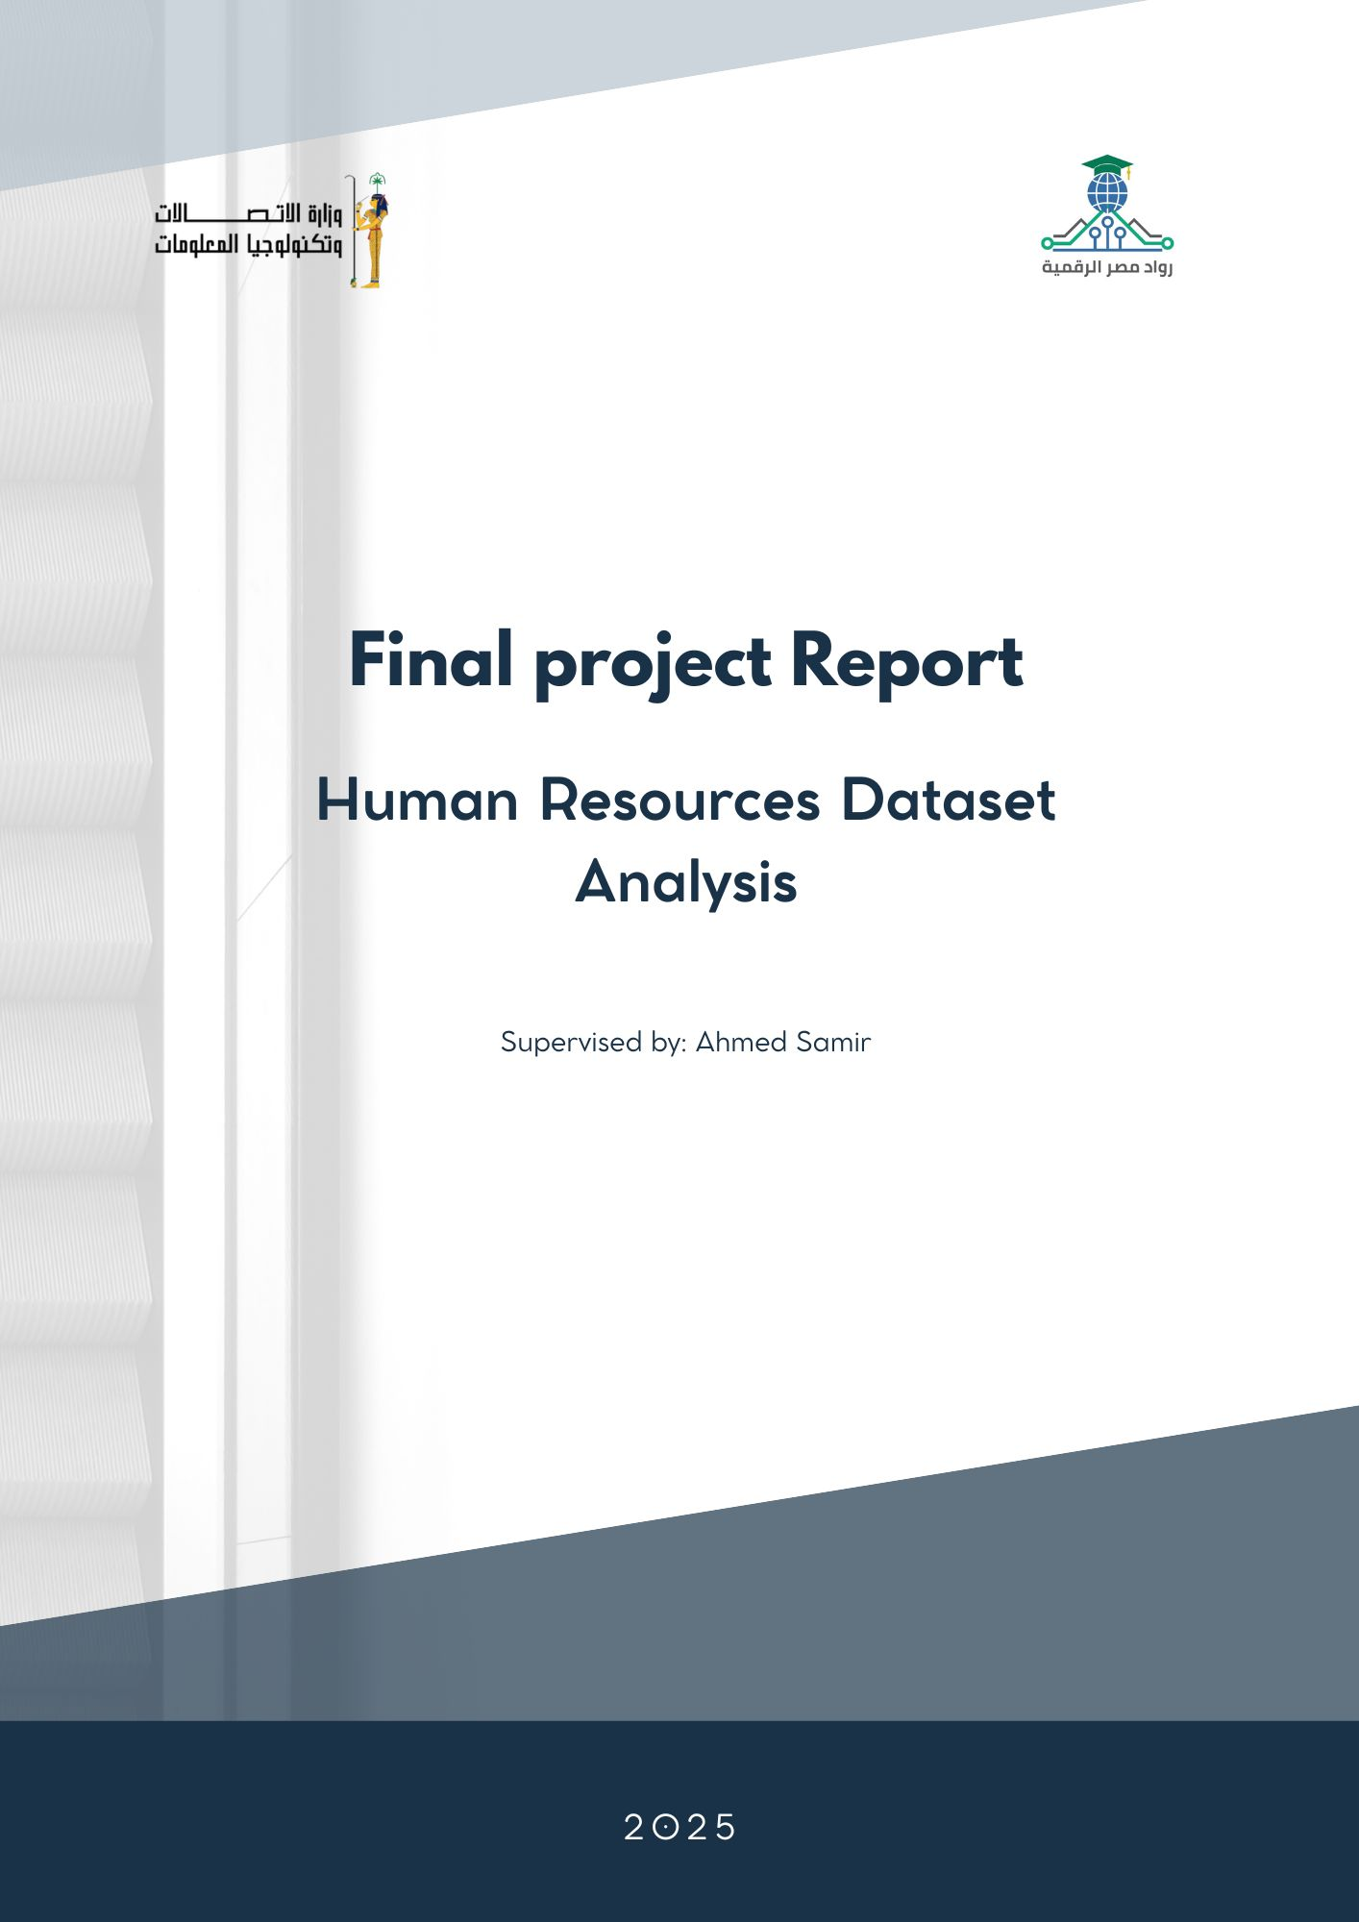

Contents

- Chapter 1: Introduction 4
  - Project Overview
  - Importance of HR Analytics
  - Project Objectives
  - Project Phases

- Chapter 2: Data Modeling and Preprocessing 6

  - Introduction
  - Data Understanding and Initial Inspection
  - Data Type
  - Data Preparation and Integration
  - Data Cleaning
  - Feature Engineering
  - Tools and Technologies Used
  - Output of this phase
  - Schema………………………………………………………………………….…………………………………….
- Chapter 3: Analytical Questions ………………………………………………………..………………… 32

  - Overview Dashboard ……………………………………………………………………………………………...
  - Employee Overview ………………………………….…………………………………………………………………….
  - Employee Attrition Analysis ………………………………………………………………………………..
  - Salary Analysis and Insights …………………………………………………………………………….….
  - Performance Analysis ……………………………………………………………………………..……………..
- Chapter 4: Insights and Visualizations …………………………………………………………………….73
- Chapter 5: Recommendations……………………………….…………………………………………………84

Introduction

1.1 Project Overview
This project focuses on analyzing Human Resources (HR) data to better understand employee behavior, performance, and workforce trends.
The dataset includes various aspects such as employee demographics, job roles, salaries, performance ratings, satisfaction levels, and tenure details.
By cleaning, organizing, and analyzing this data, the project aims to extract meaningful insights that can support strategic decision-making within the organization.

1.2 Importance of HR Analytics
HR analytics plays a crucial role in modern organizations. It helps transform raw HR data into actionable insights that can lead to better decision-making and improved organizational performance.
Through proper data analysis, companies can:
- Identify factors that influence employee retention and attrition.
- Detect issues related to salary structures, promotions, and training opportunities.
- Monitor performance trends to improve employee engagement.
- Support workforce planning and resource allocation more efficiently.
- In short, analyzing HR data provides organizations with a clear understanding of their workforce and helps them build a more data-driven HR strategy.

1.3 Project Objectives
The main objectives of this project are to:
- Clean and preprocess the HR dataset to ensure high data quality.
- Explore and analyze key HR metrics such as salary, performance, satisfaction, and tenure.
- Identify patterns and relationships between employee attributes and outcomes.
- Engineer new features (e.g., tenure groups, training ratios, salary bands) to enrich the analysis.
- Provide meaningful visualizations and insights to support strategic HR decisions.

1.5 Project Phases
The project is structured into the following main phases to ensure a smooth flow of work and clear deliverables:

Phase 1: Data Modeling, Cleaning, and Preprocessing
This phase involves building a data model, cleaning the dataset by handling missing values and duplicates, standardizing formats, and preparing the data to be ready for analysis. Tools used include Excel, SQL, and Python (pandas, Matplotlib). The expected deliverables are a cleaned dataset and a preprocessing notebook.

Phase 2: Defining Analysis Questions
In this phase, key questions for data analysis are identified based on the dataset, focusing on inquiries important to organizational decision-makers. Examples include exploring the relationship between employee age and satisfaction levels. Tools include Excel, SQL, and Python. Deliverables include a defined set of analysis questions.

Phase 3: Forecasting and Predictive Analysis
This phase focuses on determining forecasting questions and applying predictive models to answer them, utilizing trends found in the data. Python libraries such as scikit-learn, pandas, and Matplotlib are used. Deliverables are visualization plots that illustrate the forecasting results.

Phase 4: Visualization Dashboard and Final Presentation
The final phase includes creating a comprehensive Tableau dashboard to visualize answers and insights clearly. In addition, a final report and presentation are prepared to summarize the entire project work including data analysis, model development, and deployment. Tools include SQL, Python, and Tableau. Deliverables comprise the dashboard, final report, and presentation

Chapter 2

Data Modeling, Cleaning, and Preprocessing

2.1 Introduction
Before performing any meaningful data analysis or building predictive models, it is essential to ensure the dataset is clean, well-structured, and reliable. Raw data often contains inconsistencies, missing values, duplicates, and irrelevant information that can negatively impact the quality of analysis. Therefore, this chapter focuses on the foundational step of the data analytics process: data modeling and preprocessing.
The primary goal of this phase is to prepare the HR dataset for further analysis by performing cleaning, formatting, and initial feature engineering tasks. The process involves inspecting the data, identifying data quality issues, handling missing or incorrect entries, and creating new variables that will enhance the analytical value of the dataset.

2.2 Data Understanding and Initial Inspection
The dataset used in this project was provided as an Excel file containing five sheets, each serving a different purpose in the analysis:

Sheet Name | Rows | Columns | Description
SatisfactionLevel | 5 | 2 | Satisfaction categories and their descriptions.
RatingLevel | 5 | 2 | Rating scales used for evaluations.
PerformanceRating | 6,709 | 11 | Contains detailed performance review data.
Employee | 1,470 | 23 | Main dataset with employee demographic and job info.
EducationLevel | 5 | 2 | Definitions of education levels.

The main focus of the analysis is on the Employee and PerformanceRating sheets, as they contain the bulk of the employee data. The other three sheets serve as lookup tables that support interpretation of categorical variables.

2.3 Data Type
The dataset includes a combination of:
- Numerical Variables:
These include continuous or discrete values used to quantify aspects of the employee profile. Examples:
  - Age, Salary, DistanceFromHome (KM)
  - Performance-related scores such as EnvironmentSatisfaction, JobSatisfaction, SelfRating, ManagerRating
  - Tenure-based columns such as YearsAtCompany, YearsSinceLastPromotion, YearsInMostRecentRole

- Categorical Variables:
These represent groupings or classifications. They are used to segment employees into distinct categories:
  - Gender, Department, JobRole, EducationField, BusinessTravel, MaritalStatus, State, Ethnicity
  - Satisfaction and performance levels like JobSatisfactionLevel, EnvironmentSatisfactionLevel, RatingLevel

- Binary/Yes-No Variables:
Represent true/false or yes/no values that indicate presence or absence of a condition:
  - OverTime, Attrition

- Date and Time Variables:
Used to capture time-based events or track employee history:
  - ReviewDate, HireDate

- Identifier and Descriptive Fields:
These are used for identification and labeling, not for analysis directly:
  - EmployeeID, PerformanceID, FirstName, LastName
This classification helps guide the preprocessing and feature engineering steps. Numerical variables may be used in statistical analysis or modeling, while categorical variables may require encoding. Date fields will be useful for calculating tenure, performance timelines, or identifying trends over time.

2.4 Data Preparation and Integration
This stage involves collecting data from multiple sources, cleaning it to remove errors or inconsistencies, and combining it into a unified dataset. The goal is to ensure that the data is accurate, complete, and ready for analysis.

Data Preparation and Integration In Excel
Reducing the Number of Tables (Merge in Power Query)
Since the dataset contained many separate tables, we decided to merge those that shared common keys:
- Employee ↔ Education Level
  - Common column: Education ID.
  - Goal: enrich the Employee table with the actual Education Level instead of just an ID .

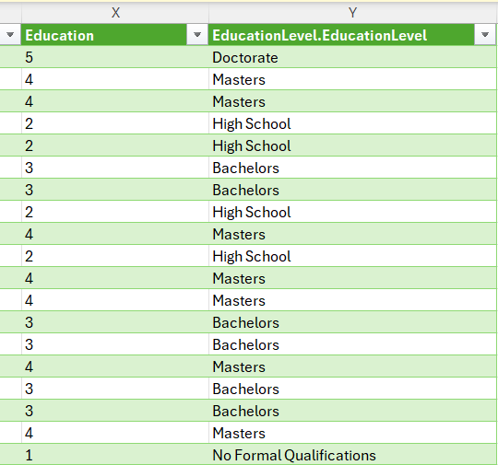

- Performance Rating ↔ Rating Level
  - Common column: Rating ID.
  - Goal: bring descriptive rating levels (e.g., Acceptable, Exceeds…) directly into the Performance Rating table.
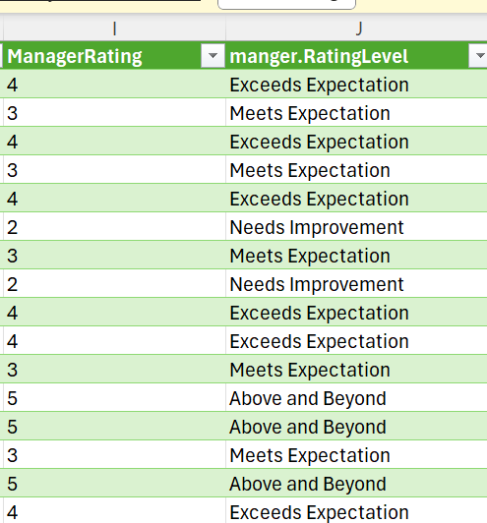

- Performance Rating ↔ Satisfaction Level
  - Common columns:
    - Environment Satisfaction
    - Job Satisfaction
    - Relationship Satisfaction
    - Work Life Balance
  - The Satisfaction Level table was split into four separate tables, and each was merged with its respective column.
- All these merges were performed in Power Query.

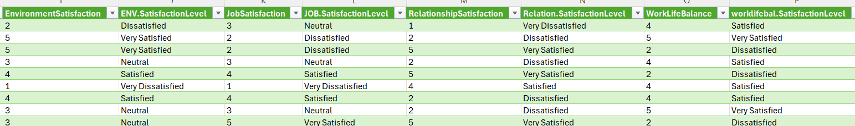

Data Preparation and Integration In SQL
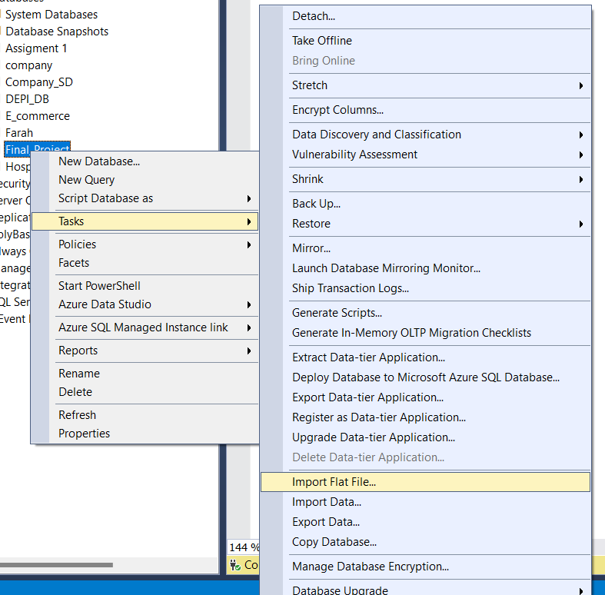
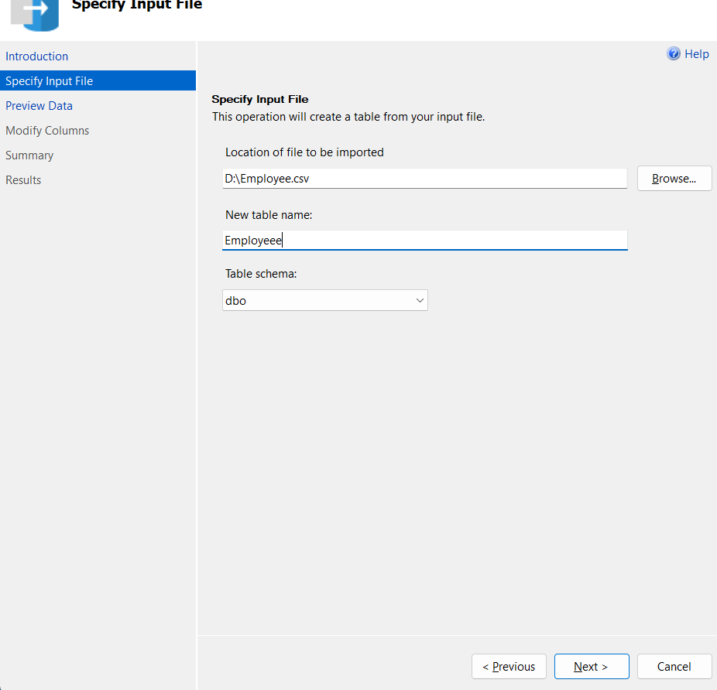
Create Database & Import Files: create database Final_Project
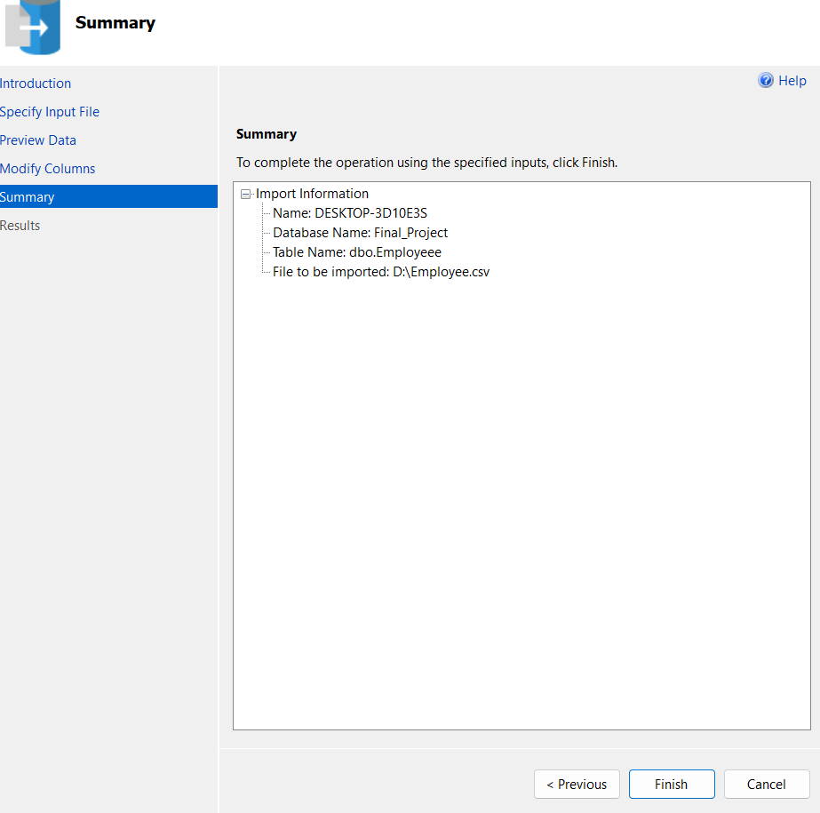
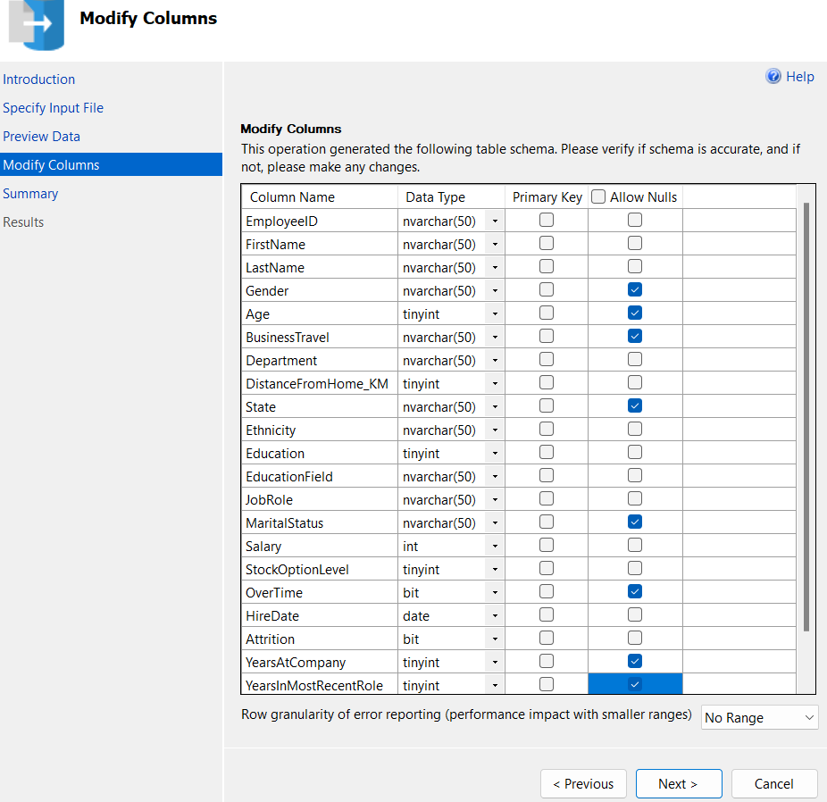
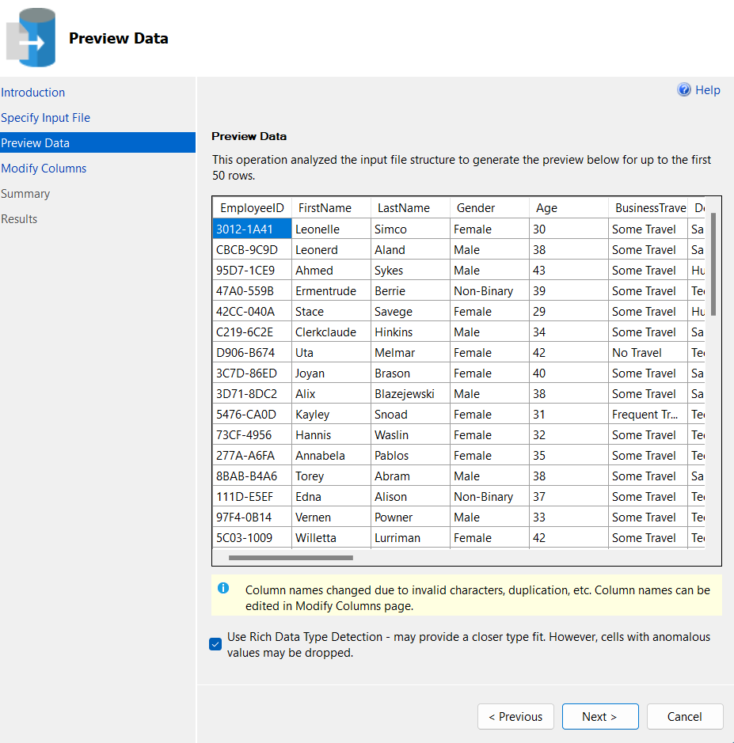
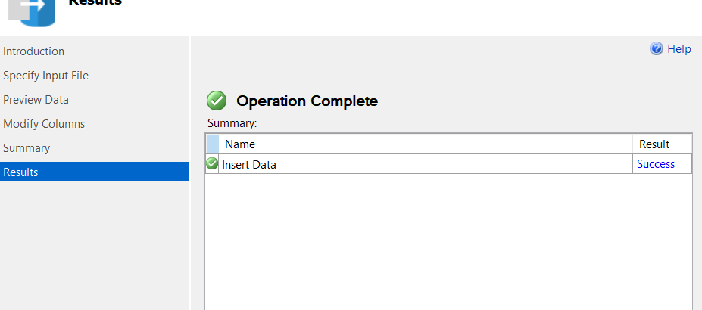

Set Constraints :

--set primary key & forgien key

ALTER TABLE Employee
ADD CONSTRAINT PK_Employee PRIMARY KEY (EmployeeID);

ALTER TABLE PerformanceRating
ADD CONSTRAINT PK_PerformanceRating PRIMARY KEY (PerformanceID),
CONSTRAINT FK_Performance_Employee FOREIGN KEY (EmployeeID) REFERENCES Employee(EmployeeID);

ALTER TABLE SatisfiedLevel
ADD CONSTRAINT PK_SatisfiedLevel PRIMARY KEY (SatisfactionID);

ALTER TABLE PerformanceRating
ADD CONSTRAINT FK_Performance_EnvSat FOREIGN KEY (EnvironmentSatisfaction)
REFERENCES SatisfiedLevel(SatisfactionID),

CONSTRAINT FK_Performance_JobSat FOREIGN KEY (JobSatisfaction)
REFERENCES SatisfiedLevel(SatisfactionID),

CONSTRAINT FK_Performance_RelSat FOREIGN KEY (RelationshipSatisfaction)
REFERENCES SatisfiedLevel(SatisfactionID);

ALTER TABLE PerformanceRating
ADD CONSTRAINT FK_Performance_balsat FOREIGN KEY (worklifebalance)
REFERENCES SatisfiedLevel(SatisfactionID)

ALTER TABLE RatingLevel
ADD CONSTRAINT PK_RatingLevel PRIMARY KEY (RatingID);

ALTER TABLE PerformanceRating
ADD CONSTRAINT FK_Performance_SelfRating FOREIGN KEY (SelfRating)
REFERENCES RatingLevel(RatingID),

CONSTRAINT FK_Performance_ManagerRating FOREIGN KEY (ManagerRating)
REFERENCES RatingLevel(RatingID);

ALTER TABLE EducationLevel
ADD CONSTRAINT PK_EducationLevel PRIMARY KEY (EducationLevelID);

ALTER TABLE Employee
ADD CONSTRAINT FK_Employee_Education FOREIGN KEY (Education)
REFERENCES EducationLevel(EducationLevelID);

Data Preparation and Integration In python

1. Environment Setup
Before starting data transformation, necessary Python libraries such as pandas and numpy were imported to facilitate data processing, handling, and analysis.
- # import libraries
import numpy as np
import pandas as pd

2. Data Loading
The HR data was loaded from an Excel file containing 5 sheets corresponding to different tables (SatisfactionLevel, RatingLevel, PerformanceRating, Employee, EducationLevel). All sheets were read simultaneously into a dictionary of pandas DataFrames, where each sheet's name serves as the key for its corresponding DataFrame.
- # Read file
df = pd.read_excel('C:/Users/عمرو/Downloads/DEPI/Dataset/FINAL_PROJECT-1.xlsx', sheet_name=None)

3. Data Merging
The dataset was initially spread across five separate tables (Employee, EducationLevel, PerformanceRating, RatingLevel, SatisfactionLevel). To simplify analysis, the following merging operations were applied:
The PerformanceRating table was merged with the SatisfactionLevel table multiple times to map different satisfaction scores—JobSatisfaction, EnvironmentSatisfaction , worklifebalance and RelationshipSatisfaction—using the appropriate satisfaction IDs. This ensured a detailed view of employee satisfaction levels.
# Merge Job Satisfaction
m1 = df['PerformanceRating'].merge(
df['SatisfiedLevel'],
left_on="JobSatisfaction",
right_on="SatisfactionID",
how="inner"
).rename(columns={"SatisfactionLevel": "JobSatisfactionLevel"}).drop("SatisfactionID", axis=1)

# Merge Environment Satisfaction
m2 = m1.merge(
df['SatisfiedLevel'],
left_on="EnvironmentSatisfaction",
right_on="SatisfactionID",
how="left"
).rename(columns={"SatisfactionLevel": "EnvironmentSatisfactionLevel"}).drop("SatisfactionID", axis=1)

# Merge Relationship Satisfaction
m3 = m2.merge(
df['SatisfiedLevel'],
left_on="RelationshipSatisfaction",
right_on="SatisfactionID",
how="left"
).rename(columns={"SatisfactionLevel": "RelationshipSatisfactionLevel"}).drop("SatisfactionID", axis=1)

# Merge WorkLifeBalance Satisfaction
merged1 = m3.merge(
df['SatisfiedLevel'],
left_on="WorkLifeBalance",
right_on="SatisfactionID",
how="left"
).rename(columns={"SatisfactionLevel": "WorkLifeBalanceSatisfaction"}).drop("SatisfactionID", axis=1)

Next, the merged performance and satisfaction data were combined with the RatingLevel table to incorporate managerial ratings for each employee.
# merge PerformanceRating & SatisfiedLevel & RatingLevel
df_performance = merged1.merge(df['RatingLevel'],
left_on='ManagerRating',
right_on='RatingID',
how='inner')
Separately, the Employee table was merged with the EducationLevel table to integrate employees’ personal information with their educational background.
# merge Employee & EducationLevel
df_Employee =df['Employee'].merge(df['EducationLevel'],
left_on="Education",
right_on="EducationLevelID",
how="inner")
Finally, these two enriched datasets—the combined performance/satisfaction/manager rating data and the combined employee/education data—were merged on the EmployeeID key. This step resulted in a unified dataset containing all relevant employee details, performance metrics, satisfaction levels, and educational information, ready for subsequent cleaning and analysis.
# merge all sheets
df= df_performance.merge(df_Employee,
on="EmployeeID",
how="outer")

2.5 Data Cleaning
- Removing Unnecessary Columns
Remove columns that are no longer needed after merging the datasets. These include redundant key columns such as 'SatisfactionID', 'RatingID', 'Education', 'SatisfactionID_x', and 'SatisfactionID_y' that were used solely for joining tables. Dropping them helps to simplify the dataset and avoid confusion.

df_performance = df_performance.drop(['RatingID'], axis=1)
df_Employee= df_Employee.drop(['Education'],axis=1)

- Checking for Duplicate Rows
Check if there are any duplicated records in the dataset. Duplicates can bias analysis results, so identifying and potentially removing them is important.
In Excel
Steps:
- The entire data range was selected.
- From the Data tab in the Excel ribbon, the Remove Duplicates option was selected.
- A dialog box appeared prompting for the columns to consider when identifying duplicates. All columns were selected to ensure a full-row comparison.
- Upon clicking OK.
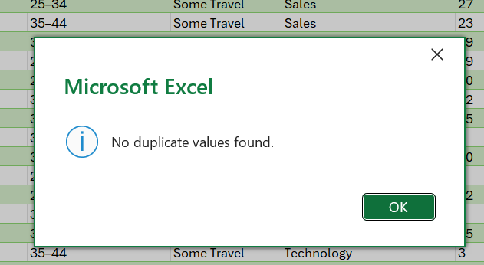

In SQL

--cleaning by check duplication

SELECT EmployeeID, COUNT(*) AS CountDup
FROM Employee
GROUP BY EmployeeID
HAVING COUNT(*) > 1;

SELECT EducationLevelID, COUNT(*) AS CountDup
FROM EducationLevel
GROUP BY EducationLevelID
HAVING COUNT(*) > 1;

SELECT PerformanceID, COUNT(*) AS CountDup
FROM PerformanceRating
GROUP BY PerformanceID
HAVING COUNT(*) > 1;

SELECT EmployeeID, ReviewDate, COUNT(*) AS CountDup
FROM PerformanceRating
GROUP BY EmployeeID, ReviewDate
HAVING COUNT(*) > 1;

SELECT RatingID, COUNT(*) AS CountDup
FROM RatingLevel
GROUP BY RatingID
HAVING COUNT(*) > 1;

SELECT SatisfactionID, COUNT(*) AS CountDup
FROM SatisfiedLevel
GROUP BY SatisfactionID
HAVING COUNT(*) > 1;

Output: NO DUPLICATE

In python
# Check for duplicate rows
print(df.duplicated().sum())
Result: 0

- Checking for Missing Values
Sum up all the missing (null) values across all columns in the dataset. Missing values can cause errors in analysis and modeling, so confirming that there are none ensures data completeness.
In Excel

=COUNTBLANK(A2:A1470)

In SQL

---cleaning by check the null

SELECT
SUM(CASE WHEN EmployeeID IS NULL THEN 1 ELSE 0 END) AS Null_EmployeeID,
SUM(CASE WHEN FirstName IS NULL THEN 1 ELSE 0 END) AS Null_FirstName,
SUM(CASE WHEN LastName IS NULL THEN 1 ELSE 0 END) AS Null_LastName,
SUM(CASE WHEN Gender IS NULL THEN 1 ELSE 0 END) AS Null_Gender,
SUM(CASE WHEN Age IS NULL THEN 1 ELSE 0 END) AS Null_Age,
SUM(CASE WHEN BusinessTravel IS NULL THEN 1 ELSE 0 END) AS Null_BusinessTravel,
SUM(CASE WHEN Department IS NULL THEN 1 ELSE 0 END) AS Null_Department,
SUM(CASE WHEN DistanceFromHome_KM IS NULL THEN 1 ELSE 0 END) AS Null_DistanceFromHome,
SUM(CASE WHEN State IS NULL THEN 1 ELSE 0 END) AS Null_State,
SUM(CASE WHEN Ethnicity IS NULL THEN 1 ELSE 0 END) AS Null_Ethnicity,
SUM(CASE WHEN Education IS NULL THEN 1 ELSE 0 END) AS Null_Education,
SUM(CASE WHEN EducationField IS NULL THEN 1 ELSE 0 END) AS Null_EducationField,
SUM(CASE WHEN JobRole IS NULL THEN 1 ELSE 0 END) AS Null_JobRole,
SUM(CASE WHEN MaritalStatus IS NULL THEN 1 ELSE 0 END) AS Null_MaritalStatus,
SUM(CASE WHEN Salary IS NULL THEN 1 ELSE 0 END) AS Null_Salary,
SUM(CASE WHEN StockOptionLevel IS NULL THEN 1 ELSE 0 END) AS Null_StockOptionLevel,
SUM(CASE WHEN OverTime IS NULL THEN 1 ELSE 0 END) AS Null_OverTime,
SUM(CASE WHEN HireDate IS NULL THEN 1 ELSE 0 END) AS Null_HireDate,
SUM(CASE WHEN Attrition IS NULL THEN 1 ELSE 0 END) AS Null_Attrition,
SUM(CASE WHEN YearsAtCompany IS NULL THEN 1 ELSE 0 END) AS Null_YearsAtCompany,
SUM(CASE WHEN YearsInMostRecentRole IS NULL THEN 1 ELSE 0 END) AS Null_YearsInMostRecentRole,
SUM(CASE WHEN YearsSinceLastPromotion IS NULL THEN 1 ELSE 0 END) AS Null_YearsSinceLastPromotion,
SUM(CASE WHEN YearsWithCurrManager IS NULL THEN 1 ELSE 0 END) AS Null_YearsWithCurrManager
FROM Employee;

SELECT
SUM(CASE WHEN EducationLevelID IS NULL THEN 1 ELSE 0 END) AS Null_EducationLevelID,
SUM(CASE WHEN EducationLevel IS NULL THEN 1 ELSE 0 END) AS Null_EducationLevel
FROM EducationLevel;

SELECT
SUM(CASE WHEN PerformanceID IS NULL THEN 1 ELSE 0 END) AS Null_PerformanceID,
SUM(CASE WHEN EmployeeID IS NULL THEN 1 ELSE 0 END) AS Null_EmployeeID,
SUM(CASE WHEN ReviewDate IS NULL THEN 1 ELSE 0 END) AS Null_ReviewDate,
SUM(CASE WHEN EnvironmentSatisfaction IS NULL THEN 1 ELSE 0 END) AS Null_EnvironmentSatisfaction,
SUM(CASE WHEN JobSatisfaction IS NULL THEN 1 ELSE 0 END) AS Null_JobSatisfaction,
SUM(CASE WHEN RelationshipSatisfaction IS NULL THEN 1 ELSE 0 END) AS Null_RelationshipSatisfaction,
SUM(CASE WHEN TrainingOpportunitiesWithinYear IS NULL THEN 1 ELSE 0 END) AS Null_TrainingOpportunitiesWithinYear,
SUM(CASE WHEN TrainingOpportunitiesTaken IS NULL THEN 1 ELSE 0 END) AS Null_TrainingOpportunitiesTaken,
SUM(CASE WHEN WorkLifeBalance IS NULL THEN 1 ELSE 0 END) AS Null_WorkLifeBalance,
SUM(CASE WHEN SelfRating IS NULL THEN 1 ELSE 0 END) AS Null_SelfRating,
SUM(CASE WHEN ManagerRating IS NULL THEN 1 ELSE 0 END) AS Null_ManagerRating
FROM PerformanceRating;

SELECT
SUM(CASE WHEN RatingID IS NULL THEN 1 ELSE 0 END) AS Null_RatingID,
SUM(CASE WHEN RatingLevel IS NULL THEN 1 ELSE 0 END) AS Null_RatingLevel
FROM RatingLevel;

SELECT
SUM(CASE WHEN SatisfactionID IS NULL THEN 1 ELSE 0 END) AS Null_SatisfactionID,
SUM(CASE WHEN SatisfactionLevel IS NULL THEN 1 ELSE 0 END) AS Null_SatisfactionLevel
FROM SatisfiedLevel;

Output: NO NULLS

In python
# Check for missing values
print(df.isnull().sum().sum())
Result: 0

- Trim Operation
The Trim operation was performed using Excel, Python, and SQL to remove unnecessary spaces from text fields.
This helped ensure data consistency and prevent mismatches in categorical values.
For example, in the EducationField column, the value "Marketing " had an extra space at the end and was corrected to "Marketing".
- Job Role and Department Alignment Check
The validation was performed using Excel, SQL, and Python to ensure consistency between job roles and departments.
After filtering the data where JobRole = "Sales Executive" and Department = "Sales", it was discovered that some Sales Executive employees were incorrectly classified under the Technology department instead of Sales.
These inconsistencies were identified and corrected to maintain accurate alignment between the JobRole and Department fields.
In Python
dept_job_count = (
df_Employee.groupby(['Department', 'JobRole'])
.size()
.reset_index(name='EmployeeCount')
.sort_values(['Department', 'EmployeeCount'], ascending=[True, False])
)
print(dept_job_count)
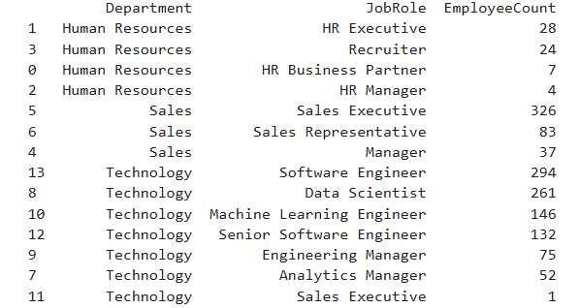

ids = df_Employee.loc[
(df_Employee['Department'] == 'Technology') &
(df_Employee['JobRole'] == 'Sales Executive'),
'EmployeeID'
]
print(" Employee IDs:")
print(ids.tolist())
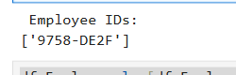
df_Employee.loc[df_Employee['EmployeeID'] == '9758-DE2F', 'Department'] = 'Sales'
# Optional check like your SQL SELECT
df_Employee.loc[df_Employee['EmployeeID'] == '9758-DE2F']

In SQL

UPDATE Employee
SET Department = 'Sales'
WHERE EmployeeID = '9758-DE2F';

select * from Employee
where EmployeeID = '9758-DE2F';

Data Validation
- Verified that all employee ages are 18 years or older.
In SQL

--Checking for Logical Employee Ages
SELECT *
FROM Employee
WHERE Age < 18 OR Age > 100;
In Python

invalid_ages = df[df["Age"] < 18]
if invalid_ages.empty:
print("No employees with age less than 18.")
else:
print("Found employees with age less than 18:")
print(invalid_ages)

- Verified that numeric values such as tenure and years at company were non-negative.

In SQL

--checking Logical Years
SELECT *
FROM Employee
WHERE YearsAtCompany < 0
OR YearsInMostRecentRole < 0
OR YearsSinceLastPromotion < 0
OR YearsWithCurrManager < 0;

In Python

invalid_age = df[df["Age"] < 18]
invalid_records = df[
(df["YearsAtCompany"] < 0) |
(df["YearsInMostRecentRole"] < 0) |
(df["YearsSinceLastPromotion"] < 0) |
(df["YearsWithCurrManager"] < 0)
]
if invalid_records.empty:
print("No negative values found in tenure-related columns.")
else:
print("Found records with negative values:")
print(invalid_records)

- Salary Outlier Detection and Correction
This step aimed to identify and correct salary outliers that were inconsistent with employees’ education level, job role, years of experience, and education field.
By cross-checking these attributes, anomalous salary values were detected and adjusted to align with the average salary of employees with similar profiles.
In SQL

--'372C-E204' 455000, education 4, years at company 0

Select *
from Employee
where Education = '4'and JobRole = 'Data Scientist' and YearsAtCompany = 0
and EducationField ='Computer Science';

select avg(salary) AS average_salary
from Employee
where Education = '4'and JobRole = 'Data Scientist' and YearsAtCompany = 0
and EducationField ='Computer Science';

UPDATE Employee
SET Salary = (select avg(salary)
from Employee
where Education = '4'and JobRole = 'Data Scientist' and YearsAtCompany = 0
and EducationField ='Computer Science')
WHERE EmployeeID = '372C-E204';

-- AFC3-E23F' 423941, education:2, years at company: 1
Select *
from Employee
where Education = '2'and JobRole = 'Data Scientist' and YearsAtCompany = 1;

select avg(salary) AS average_salary
from Employee
where Education = '2'and JobRole = 'Data Scientist' and YearsAtCompany = 1;

UPDATE Employee
SET Salary = (select Salary
from Employee
where EmployeeID = '1053-41B1')
where EmployeeID = 'AFC3-E23F';

--801E-9D0E : software engineer 439641, education : 4, years at company : 1
Select *
from Employee
where Education = '4'and JobRole = 'Software Engineer' and YearsAtCompany = 1
and EducationField = 'Information Systems';

select AVG(Salary) as avg_salary
from Employee
where Education = '4'and JobRole = 'Software Engineer' and YearsAtCompany = 1
and EducationField = 'Information Systems';

UPDATE Employee
SET Salary = (select avg(salary)
from Employee
where Education = '4'and JobRole = 'Software Engineer' and YearsAtCompany = 1
and EducationField = 'Information Systems')
WHERE EmployeeID = '801E-9D0E';

select salary , e.EmployeeID
from employee e
where e.EmployeeID in ('372C-E204' , 'AFC3-E23F' , '801E-9D0E')

in python

# -- '372C-E204' | Data Scientist | Education 4 | YearsAtCompany 0 | Computer Science
mask1 = (
(df_Employee['EducationLevelID'] == 4) &
(df_Employee['JobRole'] == 'Data Scientist') &
(df_Employee['YearsAtCompany'] == 0) &
(df_Employee['EducationField'] == 'Computer Science')
)
avg_salary_1 = df_Employee.loc[mask1, 'Salary'].mean()
df_Employee.loc[df_Employee['EmployeeID'] == '372C-E204', 'Salary'] = avg_salary_1
# -- 'AFC3-E23F' | Replace salary with employee '1053-41B1'
salary_1053 = df_Employee.loc[df_Employee['EmployeeID'] == '1053-41B1', 'Salary'].values[0]
df_Employee.loc[df_Employee['EmployeeID'] == 'AFC3-E23F', 'Salary'] = salary_1053
# -- '801E-9D0E' | Software Engineer | Education 4 | YearsAtCompany 1 | Info Systems
mask3 = (
(df_Employee['EducationLevelID'] == 4) &
(df_Employee['JobRole'] == 'Software Engineer') &
(df_Employee['YearsAtCompany'] == 1) &
(df_Employee['EducationField'] == 'Information Systems')
)
avg_salary_3 = df_Employee.loc[mask3, 'Salary'].mean()
df_Employee.loc[df_Employee['EmployeeID'] == '801E-9D0E', 'Salary'] = avg_salary_3
# verify updates
print(df_Employee.loc[df_Employee['EmployeeID'].isin(['372C-E204', 'AFC3-E23F', '801E-9D0E']),
['EmployeeID', 'Salary']])

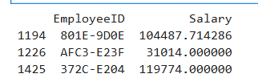

2.6 Feature Engineering
New columns were created to support analysis:
- Full Name: Merged FirstName and LastName into a new column FullName to have the complete employee name in one field.
In Excel
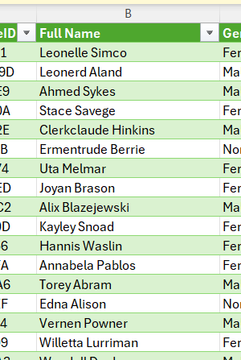

In SQL
ALTER TABLE Employee
ADD FullName NVARCHAR(100);

UPDATE Employee
SET FullName = FirstName + ' ' + LastName;

In Python

# Create a new column for full name
df['FullName']=df['FirstName']+' ' +df['LastName']
df = df.drop(['FirstName','LastName'], axis=1)

- AgeGroup: Categorizes employees into age ranges (e.g., 18-24, 25-34, 35-44, 45-51, 51+) using predefined age bins. This helps analyze employee demographics and trends across different life stages.

In Excel

=IF(D877<=29,"18–29",
IF(D877<=39,"30–39",
IF(D877<=49,"40–49",
"50+")))
In SQL

-- Create column Age group in Employee table

select min(Age) as 'Min_age', max(Age) as 'Max_Age'
from employee;

ALTER TABLE Employee
ADD AgeGroup VARCHAR(20);

UPDATE Employee
SET AgeGroup =
CASE
WHEN Age BETWEEN 18 AND 29 THEN '18-29'
WHEN Age BETWEEN 30 AND 39 THEN '30-39'
WHEN Age BETWEEN 40 AND 49 THEN '40-49'
ELSE '50+'
END

In Python

bins = bins = [17, 29, 39, 49, np.inf]
labels = ["18-29", "30-39", "40-49","50+"]
df_Employee["AgeGroup"] = pd.cut(df_Employee["Age"], bins=bins, labels=labels, right=True)
df_Employee[["Age", "AgeGroup"]].head(20)

- TrainingRatio: Represents the ratio of training opportunities an employee took relative to those available within the year. It indicates the extent of employee participation in training and development programs.
In Excel
=IF(Training Opportunities Within Year =0,0, Training Opportunities Taken / Training Opportunities Within Year)

In SQL

--Add TrainingRatio column in table PerformanceRating

ALTER TABLE PerformanceRating
ADD TrainingRatio DECIMAL(5,2);

UPDATE PerformanceRating
SET TrainingRatio =
CASE
WHEN TrainingOpportunitiesWithinYear = 0 THEN 0
ELSE CAST(TrainingOpportunitiesTaken AS DECIMAL(5,2))
/ CAST(TrainingOpportunitiesWithinYear AS DECIMAL(5,2))
END;

In Python

df["TrainingRatio"] = (
df["TrainingOpportunitiesTaken"] / df["TrainingOpportunitiesWithinYear"].replace(0, 1)
).round(2)
print(df[["TrainingOpportunitiesWithinYear", "TrainingOpportunitiesTaken", "TrainingRatio"]].head(20))

- TenureCompany: Groups employees based on their total years at the company into tenure bins such as 0-2, 3-5, 6-10, and 10+ years. This classification aids in analyzing employee retention and experience levels.

In Excel

=IF(Years At Company <3,"0-2 "
,IF(Years At Company <6,"3-5 ",
IF(Years At Company <11,"6-10","10+")))

In SQL

--Add TenureCompany column in Employee Table

ALTER TABLE Employee
ADD TenureCompany AS
CASE
WHEN YearsAtCompany < 2 THEN '0–1'
WHEN YearsAtCompany BETWEEN 2 AND 5 THEN '2–5'
WHEN YearsAtCompany BETWEEN 6 AND 10 THEN '6–10'
ELSE '10+'
END;

In Python

- tenure_bins = [0, 2, 5, 10, np.inf]
tenure_labels = ["0-2", "3-5", "6-10", "10+"]
df["TenureCompany"] = pd.cut(
df["YearsAtCompany"],
bins=tenure_bins,
labels=tenure_labels,
right=True
)
- df[["YearsAtCompany", "TenureCompany"]].head(20)

- Salary Level : Calculates salary bands for each employee within their job role.

Logic:
  - Compare each employee’s salary only against others with the same Job Role.
  - If salary ≤ 33rd percentile → "Low"
  - If salary ≤ 66th percentile → "Medium"
  - Otherwise → "High"

Purpose:
Enables fair salary comparison within the same role (not across the whole company).
Helps identify employees in lower salary bands who may be underpaid relative to peers.

Useful for HR insights such as:
  - Linking salary level with performance ratings or satisfaction.
  - Detecting potential pay gaps.
  - Supporting decisions on promotions, salary adjustments, or retention strategies

In Excel
=IF([@Salary] <= PERCENTILE.INC(FILTER([Salary], [JobRole]=[@JobRole]),0.33),"Low",
IF([@Salary]<=PERCENTILE.INC(FILTER([Salary], [JobRole]=[@JobRole]),0.66),"Medium","High"))

In SQL

-- Create column Salary Level in Employee table

ALTER TABLE Employee
ADD SalaryLevel NVARCHAR(10);

WITH SalaryLevel AS (
SELECT
EmployeeID,
PERCENTILE_CONT(0.33) WITHIN GROUP (ORDER BY Salary)
OVER (PARTITION BY JobRole) AS P33,
PERCENTILE_CONT(0.66) WITHIN GROUP (ORDER BY Salary)
OVER (PARTITION BY JobRole) AS P66,
Salary
FROM Employee
)
UPDATE E
SET SalaryLevel = CASE
WHEN E.Salary <= S.P33 THEN 'Low'
WHEN E.Salary <= S.P66 THEN 'Medium'
ELSE 'High'
END
FROM Employee E
JOIN SalaryLevel S ON E.EmployeeID = S.EmployeeID;
select * from PerformanceRating

In Python

def label_salary(group):
q33 = group["Salary"].quantile(0.33)
q66 = group["Salary"].quantile(0.66)
return group["Salary"].apply(
lambda x: "Low" if x <= q33 else ("Medium" if x <= q66 else "High")
)
df["SalaryLevel"] = df.groupby("JobRole", group_keys=False).apply(label_salary)
df

- Current Date

The Current Date column was created to estimate each employee’s current or last working date based on their hiring date and total years at the company.
It was calculated as :
( Current Date = Hire Date + Years At Company )
This column was generated to maintain consistency across tools.
It helps in validating other time-based fields (such as Review Date) and ensures accurate analysis of employee tenure and performance timelines.

In Excel
Date.AddYears([HireDate], [YearsAtCompany])

In SQL
ALTER TABLE Employee
ADD CurrentDate DATE;

UPDATE Employee
SET CurrentDate = DATEADD(YEAR, YearsAtCompany, HireDate);

In Python
df_Employee['HireDate'] = pd.to_datetime(df_Employee['HireDate'])

df_Employee['CurrentDate'] = df_Employee.apply(
lambda row: row['HireDate'] + relativedelta(years=row['YearsAtCompany']),
axis=1
)

- Review check
The ReviewCheck column was added to the PerformanceRating table to validate the logical relationship between each employee’s HireDate, ReviewDate, and CurrentDate.
This step was essential to ensure the accuracy and reliability of performance evaluation data.
This validation ensures that all performance reviews occur within the employee’s active employment period — preventing inaccurate data analysis and ensuring that only valid, logical records are included in further evaluations.

In Excel
if [ReviewDate] < [Employee.HireDate] then "Invalid - Before Hire"
else if [ReviewDate] > [Employee.Current date] and [Employee.Attrition] = "Yes" then "Invalid - After Exit"
else "Valid

In SQL
ALTER TABLE PerformanceRating
ADD ReviewCheck NVARCHAR(50);

UPDATE P
SET ReviewCheck =
CASE
WHEN P.ReviewDate < E.HireDate THEN 'Invalid - Before Hire'
WHEN (P.ReviewDate > E.CurrentDate AND E.Attrition = 1) THEN 'Invalid - After Exit'
ELSE 'Valid'
END
FROM PerformanceRating P
JOIN Employee E ON P.EmployeeID = E.EmployeeID;

DELETE FROM PerformanceRating
WHERE ReviewCheck LIKE 'Invalid%';

In Python
# Map the corresponding employee dates to the performance dataframe
df_performance["HireDate"] = df_performance["EmployeeID"].map(df_Employee.set_index("EmployeeID")["HireDate"])
df_performance["CurrentDate"] = df_performance["EmployeeID"].map(df_Employee.set_index("EmployeeID")["CurrentDate"])
df_performance["Attrition"] = df_performance["EmployeeID"].map(df_Employee.set_index("EmployeeID")["Attrition"])

# Now you can compare directly
df_performance["ReviewCheck"] = df_performance.apply(
lambda row: (
"Invalid - Before Hire"
if row["ReviewDate"] < row["HireDate"]
else "Invalid - After Exit"
if row["Attrition"] == "Yes" and row["ReviewDate"] > row["CurrentDate"]
else "Valid"
),
axis=1
)

valid_count = (df_performance['ReviewCheck'] == 'Valid').sum()
invalid_before = (df_performance['ReviewCheck'] == 'Invalid - Before Hire').sum()
invalid_after = (df_performance['ReviewCheck'] == 'Invalid - After Exit').sum()

print("Valid reviews:", valid_count)
print("Invalid - Before Hire:", invalid_before)
print("Invalid - After Exit:", invalid_after)

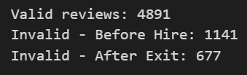
# Make sure you're working on a copy (to avoid warnings)
df_performance = df_performance.copy()
# Keep only rows where ReviewCheck == 'Valid'
df_performance = df_performance[df_performance["ReviewCheck"] == "Valid"]
# Reset the index for cleanliness (optional)
df_performance.reset_index(drop=True,inplace=True)

2.7 Tools and Technologies Used
The following tools and libraries were used in this phase:
- Excel for initial data exploration and manual checks
- SQL for querying structured data
- Python (Pandas, NumPy) for data manipulation

Output of This Phase
At the end of the data cleaning and preparation phase, the dataset was successfully cleaned, validated, and made ready for further analysis. The key outcomes of this phase are summarized below:
- All datasets were imported, reviewed, and integrated into a single structured file.
- Duplicate records were checked across all tables; none were found.
- A full scan confirmed that no missing (null) values existed in any of the columns.
- Date fields were converted into proper datetime formats.
- Unnecessary or unclear column names were renamed for clarity.
- Final cleaned dataset was exported in .xlsx format and saved for use in analysis and modeling phases.
This phase ensured the data is accurate, consistent, and well-structured — forming a reliable foundation for the next steps in exploration, visualization, and predictive analysis

Schema
Database Schema of SQL

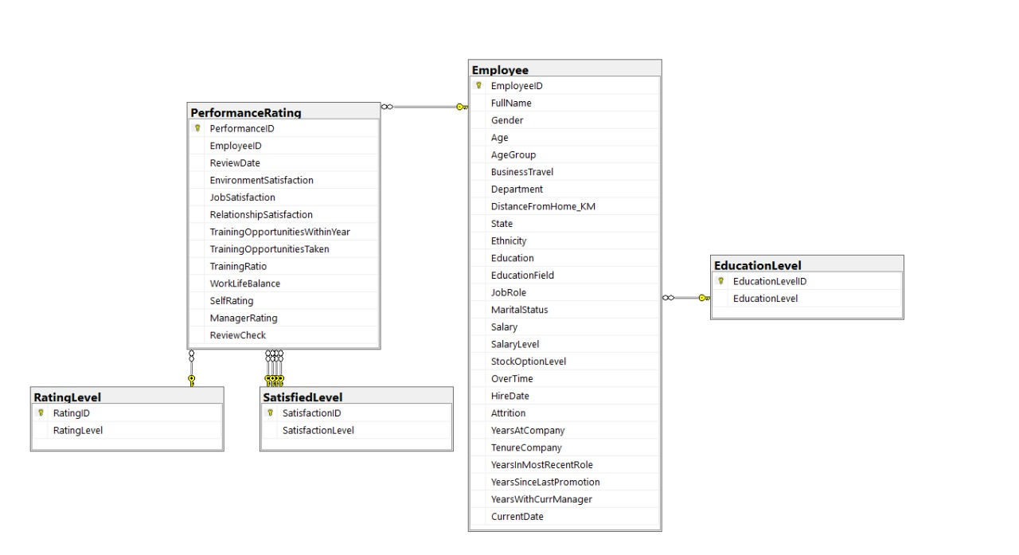

Data Modeling of Excel

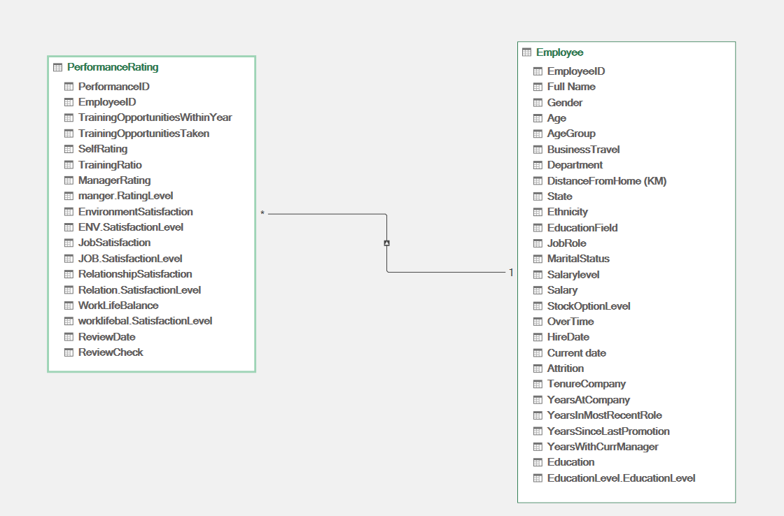

Chapter 3

Analytical Questions

3.1 Overview Dashboard

- What is the level of employee satisfaction regarding the environment,
job, relationships, and work-life balance?
business Goal: Identify areas of high and low satisfaction to improve employee engagement
In SQL :

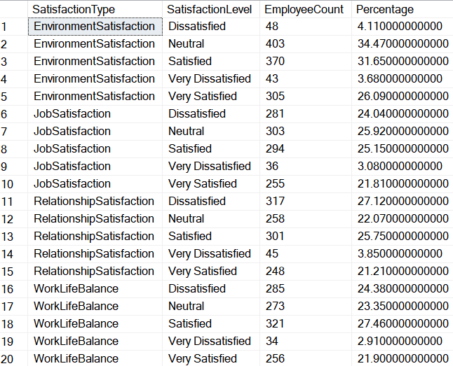

WITH LatestReview AS (
SELECT
EmployeeID,
MAX(ReviewDate) AS MaxReviewDate
FROM PerformanceRating
GROUP BY EmployeeID
),
LatestData AS (
SELECT
p.EmployeeID,
p.WorkLifeBalance,
p.EnvironmentSatisfaction,
p.JobSatisfaction,
p.RelationshipSatisfaction
FROM PerformanceRating p
JOIN LatestReview lr
ON p.EmployeeID = lr.EmployeeID AND p.ReviewDate = lr.MaxReviewDate
),
Unpivoted AS (
SELECT EmployeeID, 'WorkLifeBalance' AS SatisfactionType, WorkLifeBalance AS SatisfactionID
FROM LatestData
UNION ALL
SELECT EmployeeID, 'EnvironmentSatisfaction', EnvironmentSatisfaction
FROM LatestData
UNION ALL
SELECT EmployeeID, 'JobSatisfaction', JobSatisfaction
FROM LatestData
UNION ALL
SELECT EmployeeID, 'RelationshipSatisfaction', RelationshipSatisfaction
FROM LatestData
)
SELECT
u.SatisfactionType,
s.SatisfactionLevel,
COUNT(*) AS EmployeeCount,
ROUND(100.0 * COUNT(*) / (SELECT COUNT(*) FROM LatestData), 2) AS Percentage
FROM Unpivoted u
JOIN SatisfiedLevel s
ON s.SatisfactionID = u.SatisfactionID
GROUP BY
u.SatisfactionType,
s.SatisfactionLevel
ORDER BY
u.SatisfactionType,
s.SatisfactionLevel;

In Python :

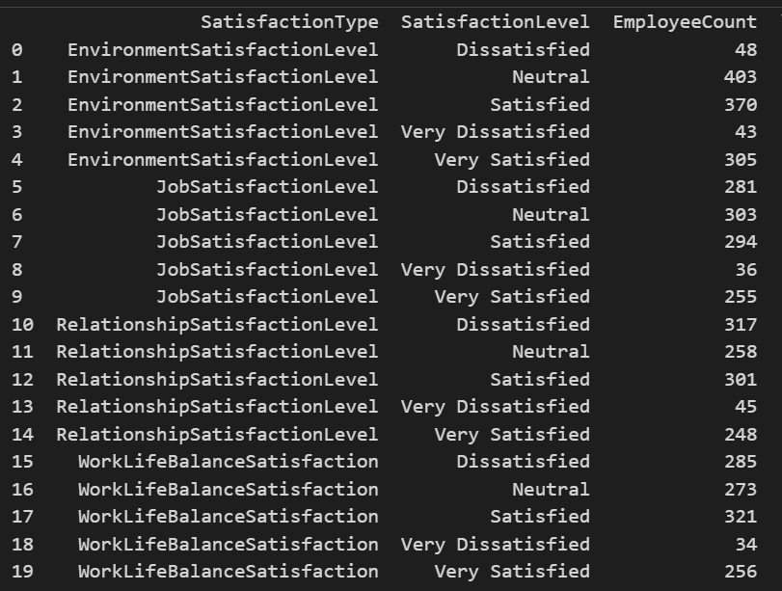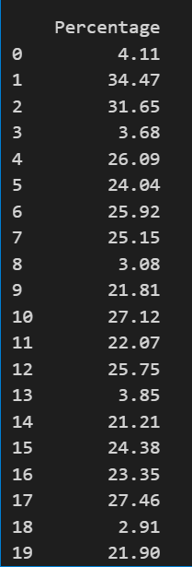

latest_review_dates = df_performance.groupby('EmployeeID')['ReviewDate'].max().reset_index()

latest_data = pd.merge(df_performance, latest_review_dates,
left_on=['EmployeeID', 'ReviewDate'],
right_on=['EmployeeID', 'ReviewDate'],
how='inner')

satisfaction_cols = [
'WorkLifeBalanceSatisfaction',
'EnvironmentSatisfactionLevel',
'JobSatisfactionLevel',
'RelationshipSatisfactionLevel'
]

unpivoted = latest_data.melt(
id_vars=['EmployeeID'],
value_vars=satisfaction_cols,
var_name='SatisfactionType',
value_name='SatisfactionLevel'
)

total_employees = latest_data['EmployeeID'].nunique()

result = (
unpivoted.groupby(['SatisfactionType', 'SatisfactionLevel'])
.size()
.reset_index(name='EmployeeCount')
)

result['Percentage'] = round(100 * result['EmployeeCount'] / total_employees, 2)

print(result)

- How has the company’s hiring trend changed over the years,and which years recorded the highest number of new hires?
business Goal: Monitor hiring patterns over the years to plan workforce growth
In SQL :

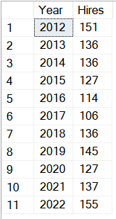

SELECT
YEAR(HireDate) AS Year,
COUNT(*) AS Hires

FROM Employee
WHERE HireDate IS NOT NULL
GROUP BY YEAR(HireDate)
ORDER BY Year;

In Python :

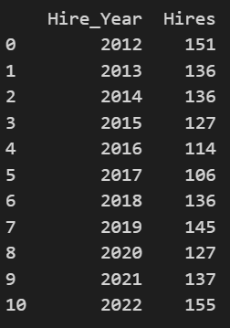
df_Employee["HireDate"] = pd.to_datetime(df_Employee["HireDate"], errors="coerce")
df_Employee["Hire_Year"] = df_Employee["HireDate"].dt.year
hiring_trend = df_Employee.groupby("Hire_Year")["EmployeeID"].count().reset_index(name="Hires")
print(hiring_trend)

- How has employee attrition varied across the years,and were there any noticeable increases or declines in certain periods?
business Goal: Detect periods of high turnover to implement retention strategies
In SQL :

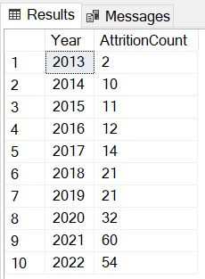

SELECT
YEAR(CurrentDate) AS Year,
COUNT(EmployeeID) AS AttritionCount
FROM Employee
WHERE Attrition = 1
GROUP BY YEAR(CurrentDate)
ORDER BY Year;

In Python :

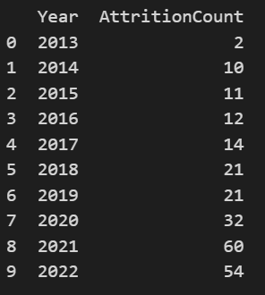
import pandas as pd
df_Employee['CurrentDate'] = pd.to_datetime(df_Employee['CurrentDate'])
df_Employee['Year'] = df_Employee['CurrentDate'].dt.year
df_attrition = df_Employee[df_Employee['Attrition'] == 'Yes']
attrition_per_year = df_attrition.groupby('Year')['EmployeeID'].count().reset_index()
attrition_per_year.rename(columns={'EmployeeID':'AttritionCount'}, inplace=True)
print(attrition_per_year)

- Which gender group has the highest attrition rate?
business Goal: Identify which gender is most at risk of leaving to target retention efforts
In SQL :

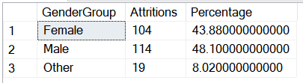

WITH GenderAttrition AS (
SELECT
CASE
WHEN Gender IN ('Male', 'Female') THEN Gender
ELSE 'Other'
END AS GenderGroup,
COUNT(*) AS Attritions
FROM Employee
WHERE Attrition = 1
GROUP BY
CASE
WHEN Gender IN ('Male', 'Female') THEN Gender
ELSE 'Other'
END
)
SELECT
GenderGroup,
Attritions,
ROUND(Attritions * 100.0 / SUM(Attritions) OVER (), 2) AS Percentage
FROM GenderAttrition;

In Python :

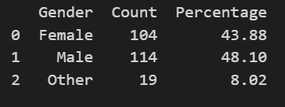
df_Employee["Gender"] = df_Employee["Gender"].apply(lambda x: x if x in ["Male", "Female"] else "Other")
df_attrition = df_Employee[df_Employee["Attrition"] == "Yes"]
attrition_counts = df_attrition.groupby("Gender")["EmployeeID"].count().reset_index(name="Count")
total_attritions = attrition_counts["Count"].sum()
attrition_counts["Percentage"] = (attrition_counts["Count"] / total_attritions * 100).round(2)

- What is the percentage of employees in each OverTime category relative to the total number of employees?
business Goal: Understand workload distribution to prevent employee burnout
In SQL :

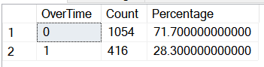

WITH OverTimeCounts AS (
SELECT
OverTime,
COUNT(*) AS Count
FROM Employee
GROUP BY OverTime
)
SELECT
OverTime,
Count,
ROUND(Count * 100.0 / SUM(Count) OVER (), 2) AS Percentage
FROM OverTimeCounts
ORDER BY OverTime;

In Python :

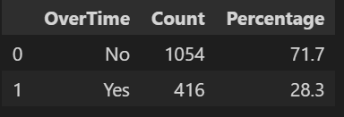
overtime_count = df_Employee['OverTime'].value_counts().reset_index()
overtime_count.columns = ['OverTime', 'Count']
overtime_count['Percentage'] = round((overtime_count['Count'] / overtime_count['Count'].sum()) * 100, 2)
overtime_count = overtime_count[['OverTime', 'Count', 'Percentage']]
overtime_count

  - Employee Overview

- How many employees are there in each department?
Business Insight Goal: Shows how employees are distributed across departments.
In SQL :

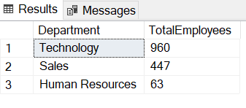
SELECT
Department,
COUNT(*) AS TotalEmployees
FROM Employee
GROUP BY Department
ORDER BY TotalEmployees DESC;

In Python :

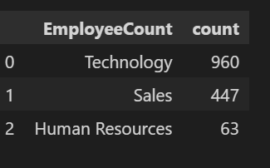
employees_per_department = (
df_Employee['Department']
.value_counts() # Count employees per department
.reset_index()
.rename(columns={'index': 'Department', 'Department': 'EmployeeCount'})
)
employees_per_department

- What is the distribution of employees by age group?
Business Insight Goal: Reveals the company’s age structure and workforce balance.
In SQL :

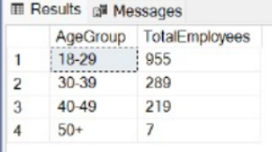
SELECT AgeGroup,
COUNT(*) AS TotalEmployees
FROM Employee
GROUP BY AgeGroup
ORDER BY AgeGroup;

In Python :

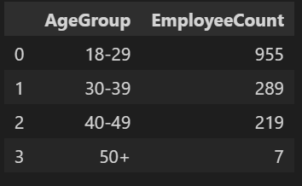
age_distribution = (
df_Employee['AgeGroup']
.value_counts()
.reset_index()
)
age_distribution.columns = ['AgeGroup', 'EmployeeCount']
age_distribution = age_distribution.sort_values(by='AgeGroup')
age_distribution

- How many employees by Gender?
Business Insight Goal: Highlights gender balance in the organization.
In SQL :

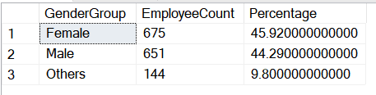

SELECT
CASE
WHEN Gender = 'Male' THEN 'Male'
WHEN Gender = 'Female' THEN 'Female'
ELSE 'Others'
END AS GenderGroup,
COUNT(*) AS EmployeeCount,
ROUND(COUNT(*) * 100.0 / (SELECT COUNT(*) FROM Employee), 2) AS Percentage
FROM Employee
GROUP BY
CASE
WHEN Gender = 'Male' THEN 'Male'
WHEN Gender = 'Female' THEN 'Female'
ELSE 'Others'
END
ORDER BY GenderGroup;

In Python :

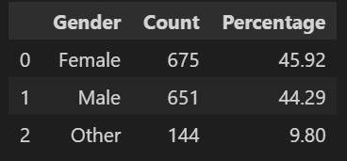

df_Employee['Gender'] = df_Employee['Gender'].apply(lambda x: x if x in ['Male', 'Female'] else 'Other')
gender_count = df_Employee['Gender'].value_counts().reset_index()
gender_count.columns = ['Gender', 'Count']
gender_count['Percentage'] = round((gender_count['Count'] / gender_count['Count'].sum()) * 100, 2)
gender_count = gender_count[['Gender', 'Count', 'Percentage']]
gender_count

- What is the total number of employees in each state?
Business Insight Goal: Shows how employees are distributed geographically across different states.
In SQL :

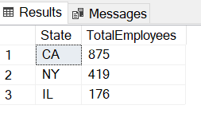

SELECT
State,
COUNT(DISTINCT EmployeeID) AS TotalEmployees
FROM Employee
GROUP BY State
ORDER BY TotalEmployees DESC;

In Python :

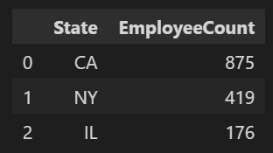
employees_per_state = (
df_Employee['State']
.value_counts()
.reset_index()
)

# Rename columns clearly
employees_per_state.columns = ['State', 'EmployeeCount']

# Sort by EmployeeCount descending
employees_per_state = employees_per_state.sort_values(by='EmployeeCount', ascending=False)

# Display the result
employees_per_state

- How many employees are married, single, or divorced?
Business Insight Goal: Shows the marital status breakdown of employees.
In SQL :

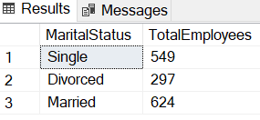

SELECT
MaritalStatus,
COUNT(*) AS TotalEmployees
FROM Employee
GROUP BY MaritalStatus;

In Python :

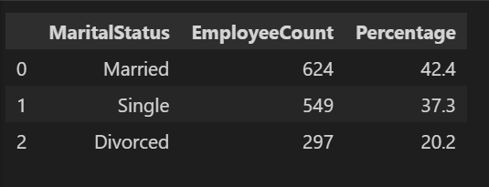
marital_status_distribution = (
df_Employee['MaritalStatus']
.value_counts()
.reset_index()
)

# Rename columns clearly
marital_status_distribution.columns = ['MaritalStatus', 'EmployeeCount']

# Add percentage of each marital status
marital_status_distribution['Percentage'] = (
(marital_status_distribution['EmployeeCount'] / marital_status_distribution['EmployeeCount'].sum()) * 100
).round(1)

# Display the result
marital_status_distribution

- How many employees are in each job role?
Business Insight Goal: Shows workforce distribution across job positions.
In SQL :

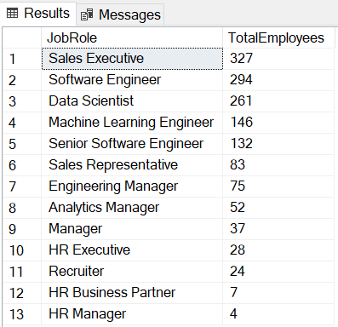

SELECT
JobRole,
COUNT(*) AS TotalEmployees
FROM Employee
GROUP BY JobRole
ORDER BY TotalEmployees DESC;

In Python :

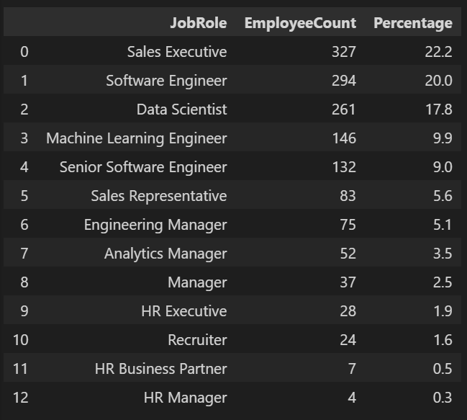

jobrole_distribution = (
df_Employee['JobRole']
.value_counts()
.reset_index()
)

# Rename columns clearly
jobrole_distribution.columns = ['JobRole', 'EmployeeCount']

# Add percentage of each job role
jobrole_distribution['Percentage'] = (
(jobrole_distribution['EmployeeCount'] / jobrole_distribution['EmployeeCount'].sum()) * 100
).round(1)

# Display the result
jobrole_distribution

- What is the total number of employees by Education Level?
Business Insight Goal: Shows how employees are distributed across different education levels.
In SQL :

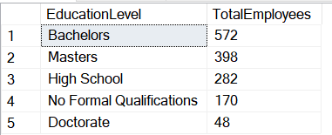

SELECT
EducationLevel,
COUNT(*) AS TotalEmployees
FROM EducationLevel e join Employee em
on e.EducationLevelID=em.Education
GROUP BY EducationLevel
ORDER BY TotalEmployees DESC

In Python :

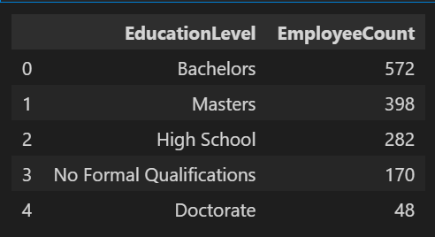
education_level_count = (
df_Employee['EducationLevel']
.value_counts()
.reset_index()
)
education_level_count.columns = ['EducationLevel', 'EmployeeCount']
education_level_count = education_level_count.sort_values(by='EmployeeCount', ascending=False)
education_level_count

- What is the total number of employees in each Education Field?
Business Insight Goal: Shows how employees are distributed by their education specialization.
In SQL :

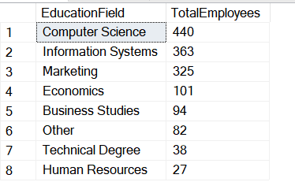

SELECT
EducationField,
COUNT(*) AS TotalEmployees
FROM Employee
GROUP BY EducationField
ORDER BY TotalEmployees DESC

In Python :

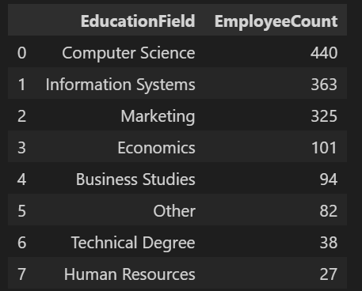

education_count = (
df_Employee['EducationField']
.value_counts()
.reset_index()
)

# Rename columns clearly
education_count.columns = ['EducationField', 'EmployeeCount']

# Sort by EmployeeCount descending
education_count = education_count.sort_values(by='EmployeeCount', ascending=False)

# Display the result
education_count

3.3 Employee Attrition Analysis

- How does age group influence employee attrition within the company?
Business Insight Goal: Understand which age groups are most vulnerable to leaving the organization to design age-specific engagement and retention initiatives.
In SQL :

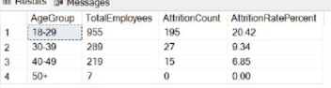

Select AgeGroup, count(*) as TotalEmployees,
SUM(CASE WHEN Attrition = 1 THEN 1 ELSE 0 END) AS AttritionCount,
CAST(ROUND(100.0 * SUM(CASE WHEN Attrition = 1 THEN 1 ELSE 0 END) / COUNT(*), 2) AS DECIMAL(5,2)) AS AttritionRatePercent
from Employee
Group by AgeGroup
ORDER BY AttritionRatePercent DESC;

In Python :

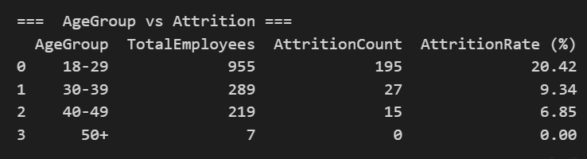
age_attrition = (
df_Employee
.groupby("AgeGroup", observed=True)
.agg(
TotalEmployees=("EmployeeID", "count"),
AttritionCount=("Attrition", lambda x: (x == "Yes").sum())
)
.reset_index()
)

age_attrition["AttritionRate (%)"] = round(
(age_attrition["AttritionCount"] / age_attrition["TotalEmployees"]) * 100, 2
)

age_attrition.sort_values("AttritionRate (%)", ascending=False, inplace=True)
print("=== AgeGroup vs Attrition ===")

print(age_attrition)

- Does the department have an impact on the attrition rate?
Business Insight Goal: Identify departments with higher turnover to prioritize leadership development, workload balancing, and team morale strategies.
In SQL :

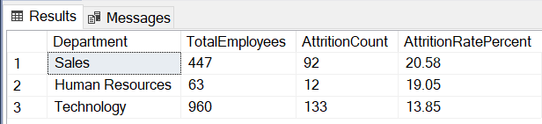

SELECT
Department,
COUNT(*) AS TotalEmployees,
SUM(CASE WHEN Attrition = 1 THEN 1 ELSE 0 END) AS AttritionCount,
CAST(ROUND(100.0 * SUM(CASE WHEN Attrition = 1 THEN 1 ELSE 0 END) / COUNT(*), 2) AS DECIMAL(5,2)) AS AttritionRatePercent

FROM Employee
GROUP BY Department
ORDER BY AttritionRatePercent DESC;

In Python :

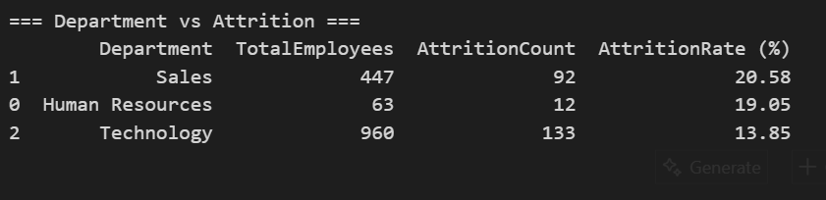
dept_attrition = (
df_Employee
.groupby("Department", observed=True)
.agg(
TotalEmployees=("EmployeeID", "count"),
AttritionCount=("Attrition", lambda x: (x == "Yes").sum())
)
.reset_index()
)

dept_attrition["AttritionRate (%)"] = round(
(dept_attrition["AttritionCount"] / dept_attrition["TotalEmployees"]) * 100, 2
)
dept_attrition.sort_values("AttritionRate (%)", ascending=False, inplace=True)
print("=== Department vs Attrition ===")
print(dept_attrition)

- Does marital status (Single, Married, Divorced) affect the likelihood of attrition?
Business Insight Goal: Explore how personal circumstances influence employee stability to implement supportive and flexible workplace policies.
In SQL :

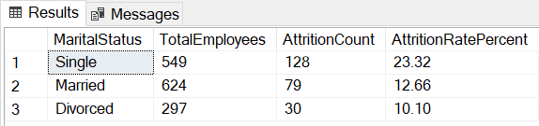

select MaritalStatus,COUNT(*) AS TotalEmployees,
SUM(CASE WHEN Attrition = 1 THEN 1 ELSE 0 END) AS AttritionCount,
CAST(ROUND(100.0 * SUM(CASE WHEN Attrition = 1 THEN 1 ELSE 0 END) / COUNT(*), 2) AS DECIMAL(5,2)) AS AttritionRatePercent
from Employee
group by MaritalStatus
ORDER BY AttritionRatePercent DESC;

In Python :

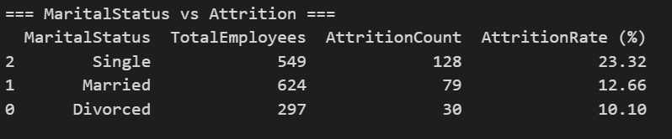
marital_attrition = (
df_Employee
.groupby("MaritalStatus", observed=True)
.agg(
TotalEmployees=("EmployeeID", "count"),
AttritionCount=("Attrition", lambda x: (x == "Yes").sum())
)
.reset_index()
)
marital_attrition["AttritionRate (%)"] = round(
(marital_attrition["AttritionCount"] / marital_attrition["TotalEmployees"]) * 100, 2
)
marital_attrition.sort_values("AttritionRate (%)", ascending=False, inplace=True)
print("=== MaritalStatus vs Attrition ===")
print(marital_attrition)

- Does the frequency of business travel increase the chances of employee turnover?
Business Insight Goal: Evaluate if extensive travel demands contribute to burnout and turnover, informing improvements in travel policy and job design.
In SQL :

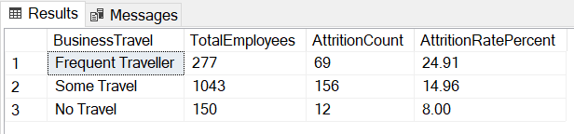

select BusinessTravel,COUNT(*) AS TotalEmployees,
SUM(CASE WHEN Attrition = 1 THEN 1 ELSE 0 END) AS AttritionCount,
CAST(ROUND(100.0 * SUM(CASE WHEN Attrition = 1 THEN 1 ELSE 0 END) / COUNT(*), 2) AS DECIMAL(5,2)) AS AttritionRatePercent
from Employee
group by BusinessTravel
ORDER BY AttritionRatePercent DESC;

In Python :

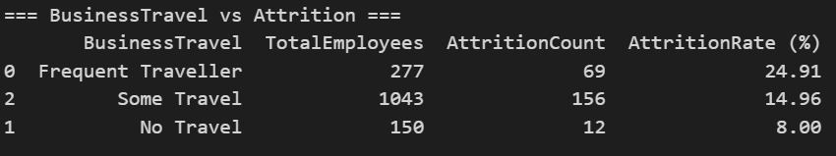
travel_attrition = (
df_Employee
.groupby("BusinessTravel", observed=True)
.agg(
TotalEmployees=("EmployeeID", "count"),
AttritionCount=("Attrition", lambda x: (x == "Yes").sum())
)
.reset_index()
)
travel_attrition["AttritionRate (%)"] = round(
(travel_attrition["AttritionCount"] / travel_attrition["TotalEmployees"]) * 100, 2
)

travel_attrition.sort_values("AttritionRate (%)", ascending=False, inplace=True)
print("=== BusinessTravel vs Attrition ===")
print(travel_attrition)

- Are there differences in attrition rates across different states?
Business Insight Goal: Pinpoint regions with higher attrition to direct retention resources and recruitment strategies more efficiently.
In SQL :

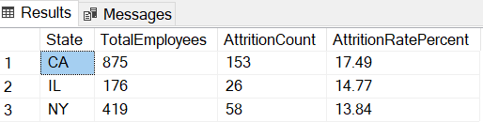

SELECT
State,COUNT(*) AS TotalEmployees,
SUM(CASE WHEN Attrition = 1 THEN 1 ELSE 0 END) AS AttritionCount,
CAST(ROUND(100.0 * SUM(CASE WHEN Attrition = 1 THEN 1 ELSE 0 END) / COUNT(*), 2) AS DECIMAL(5,2)) AS AttritionRatePercent
FROM Employee
GROUP BY State
ORDER BY AttritionRatePercent DESC;

In Python :

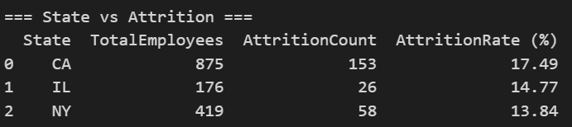
state_attrition = (
df_Employee
.groupby("State", observed=True)
.agg(
TotalEmployees=("EmployeeID", "count"),
AttritionCount=("Attrition", lambda x: (x == "Yes").sum())
)
.reset_index()
)

state_attrition["AttritionRate (%)"] = round(
(state_attrition["AttritionCount"] / state_attrition["TotalEmployees"]) * 100, 2
)
state_attrition.sort_values("AttritionRate (%)", ascending=False, inplace=True)
print("=== State vs Attrition ===")
print(state_attrition)

- Which job roles have the highest attrition rates?
Business Insight Goal: Identify job positions with the greatest turnover risk to target role-specific training, recognition, and career advancement programs.
In SQL :

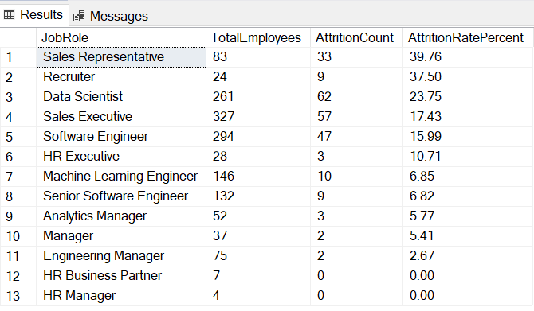

SELECT
JobRole,COUNT(*) AS TotalEmployees,
SUM(CASE WHEN Attrition = 1 THEN 1 ELSE 0 END) AS AttritionCount,
CAST(ROUND(100.0 * SUM(CASE WHEN Attrition = 1 THEN 1 ELSE 0 END) / COUNT(*), 2) AS DECIMAL(5,2)) AS AttritionRatePercent
FROM Employee
GROUP BY JobRole
ORDER BY AttritionRatePercent DESC;

In Python :

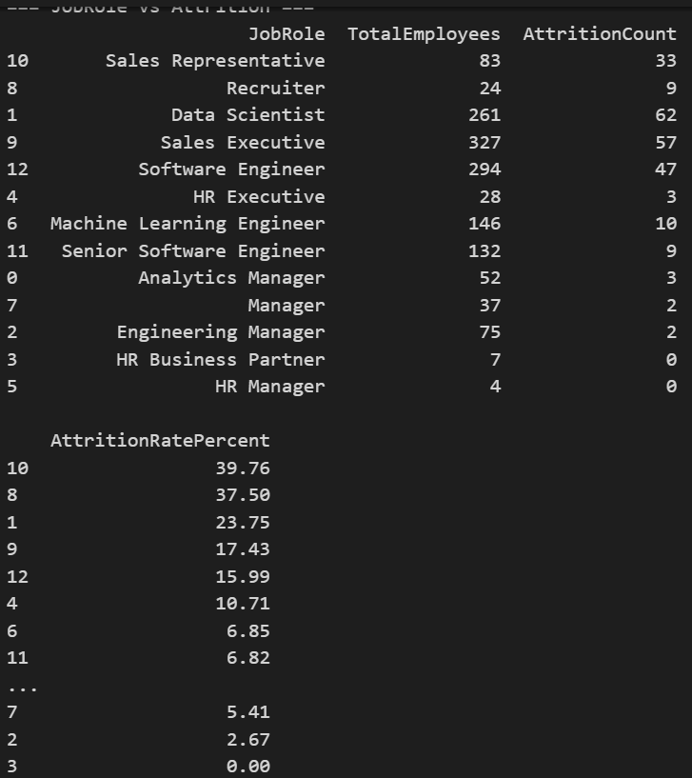
jobrole_attrition = (
df_Employee
.groupby("JobRole", observed=True)
.agg(
TotalEmployees=("EmployeeID", "count"),
AttritionCount=("Attrition", lambda x: ((x == 1) | (x == "Yes")).sum())
)
.reset_index()
)
jobrole_attrition["AttritionRatePercent"] = round(
100 * jobrole_attrition["AttritionCount"] / jobrole_attrition["TotalEmployees"], 2
)
jobrole_attrition = jobrole_attrition.sort_values(by="AttritionRatePercent", ascending=False)
print("=== JobRole vs Attrition ===")
print(jobrole_attrition)

- Do employees who work overtime have higher attrition rates compared to those who do not?
Business Insight Goal : To identify whether overtime contributes to higher employee turnover and use this insight to improve workload balance, reduce burnout, and enhance employee retention.
In SQL :

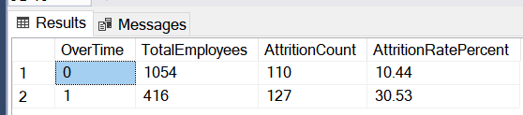

SELECT
OverTime,COUNT(*) AS TotalEmployees,
SUM(CASE WHEN Attrition = 1 THEN 1 ELSE 0 END) AS AttritionCount,
CAST(ROUND(100.0 * SUM(CASE WHEN Attrition = 1 THEN 1 ELSE 0 END) / COUNT(*), 2) AS DECIMAL(5,2)) AS AttritionRatePercent
FROM Employee
GROUP BY OverTime

In Python :

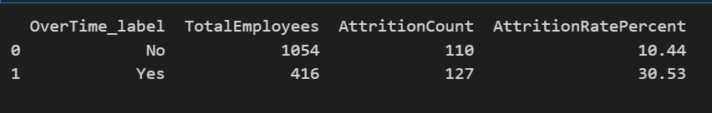
def to_binary_yesno(series):
return series.fillna("No") \
.astype(str) \
.str.strip() \
.str.lower() \
.map({"yes": 1, "y": 1, "true": 1, "1": 1,
"no": 0, "n": 0, "false": 0, "0": 0}) \
.fillna(0).astype(int)
df_Employee["Attrition_bin"] = to_binary_yesno(df_Employee["Attrition"])
df_Employee["OverTime_bin"] = to_binary_yesno(df_Employee["OverTime"])

df_Employee["OverTime_label"] = df_Employee["OverTime"].astype(str).str.strip()

result = (
df_Employee.groupby("OverTime_label")
.agg(
TotalEmployees = ("EmployeeID", "count"),
AttritionCount = ("Attrition_bin", "sum")
)
.reset_index()
)

result["AttritionRatePercent"] = (
result["AttritionCount"] / result["TotalEmployees"] * 100
).round(2)

print(result)

- How does salary level influence employee attrition within the company?
Business Insight Goal: Identify which salary segments have the highest turnover to support targeted
retention strategies and improve compensation planning.
In SQL :

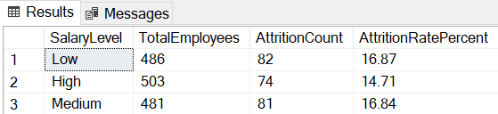

SELECT
SalaryLevel,COUNT(*) AS TotalEmployees,
SUM(CASE WHEN Attrition = 1 THEN 1 ELSE 0 END) AS AttritionCount,
CAST(ROUND(100.0 * SUM(CASE WHEN Attrition = 1 THEN 1 ELSE 0 END) / COUNT(*), 2) AS DECIMAL(5,2)) AS AttritionRatePercent
FROM Employee
GROUP BY SalaryLevel

In Python :

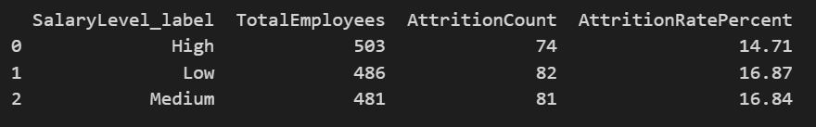
def to_binary_yesno(series):
return series.fillna("No") \
.astype(str) \
.str.strip() \
.str.lower() \
.map({"yes": 1, "y": 1, "true": 1, "1": 1,
"no": 0, "n": 0, "false": 0, "0": 0}) \
.fillna(0).astype(int)
df_Employee["Attrition_bin"] = to_binary_yesno(df_Employee["Attrition"])
df_Employee["SalaryLevel_label"] = df_Employee["SalaryLevel"].astype(str).str.strip()
result_salary = (
df_Employee.groupby("SalaryLevel_label")
.agg(
TotalEmployees=("EmployeeID", "count"),
AttritionCount=("Attrition_bin", "sum")
)
.reset_index()
)
result_salary["AttritionRatePercent"] = (
result_salary["AttritionCount"] / result_salary["TotalEmployees"] * 100
).round(2)
print(result_salary)

3.4 Salary Analysis and Insights

- What is the average salary by age group?
Business Insight Goal: Shows which age groups tend to have higher salaries — useful to understand if pay increases with experience or age.

In SQL :

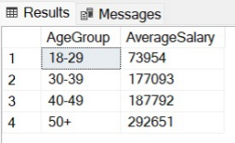

Select AgeGroup,
AVG(Salary) AS AverageSalary
From Employee
Group by AgeGroup

In Python :

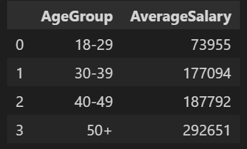
avg_salary_by_agegroup = (
df_Employee.groupby('AgeGroup')['Salary']
.mean()
.round(0) # Round to whole numbers
.astype(int)
.reset_index(name='AverageSalary')
)
avg_salary_by_agegroup

- What is the average salary by department?
Business Insight Goal: Reveals which departments offer the highest or lowest salaries, helping management identify pay disparities across divisions.
In SQL :

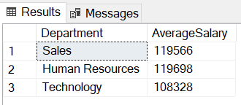

SELECT
Department,
AVG(Salary) AS AverageSalary
FROM Employee
GROUP BY Department;

In Python :

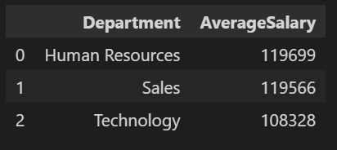
avg_salary_by_department = (
df_Employee.groupby('Department')['Salary']
.mean()
.round(0) # Round to whole numbers
.astype(int) # Convert to integer
.reset_index(name='AverageSalary')
)
avg_salary_by_department

- What is the average salary by job role?
Business Insight Goal: Highlights salary differences between job positions and helps assess the fairness and competitiveness of pay for each role.
In SQL :

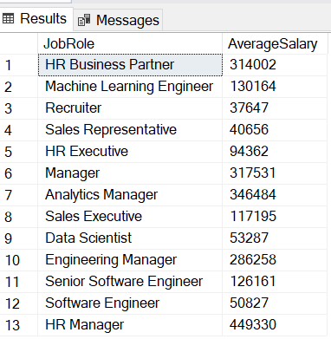

SELECT
JobRole,
AVG(Salary) AS AverageSalary
FROM Employee
GROUP BY JobRole;

In Python :

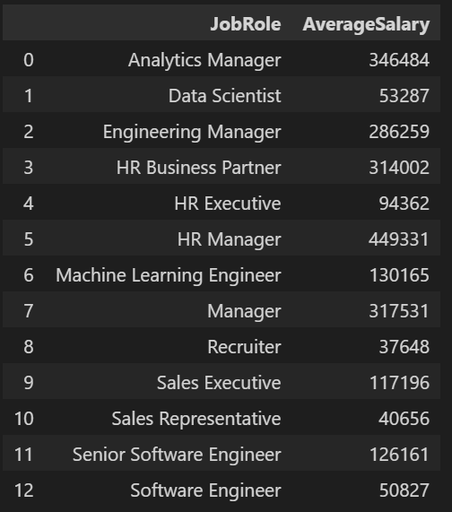
avg_salary_by_jobrole = (
df_Employee.groupby('JobRole')['Salary']
.mean()
.round(0) # Round to whole numbers
.astype(int) # Convert to integer
.reset_index(name='AverageSalary')
)

# Display the result
avg_salary_by_jobrole

- What is the average salary by educational level?
Business Insight Goal: Shows the relationship between education and salary level — useful for understanding how qualifications influence pay.
In SQL :

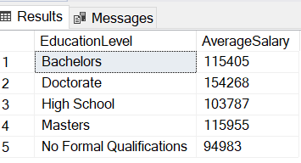

SELECT
EducationLevel,
AVG(Salary) AS AverageSalary
FROM Employee e join EducationLevel ed
on e.Education=ed.EducationLevelID
GROUP BY EducationLevel;

In Python :

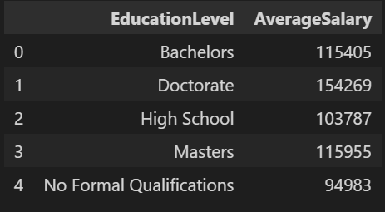
avg_salary_by_education = (
df_Employee.groupby('EducationLevel')['Salary']
.mean()
.round(0) # Round to whole numbers
.astype(int) # Convert to integer
.reset_index(name='AverageSalary')
)
avg_salary_by_education

- How are employees distributed across different salary levels within the company?
Business Insight Goal: Identify workforce concentration across salary segments to help HR understand pay structure distribution, detect imbalances, and plan compensation strategies effectively.
In SQL :

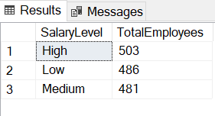

SELECT
SalaryLevel,
COUNT(EmployeeID) AS TotalEmployees
FROM Employee
GROUP BY SalaryLevel
ORDER BY SalaryLevel;

In Python :

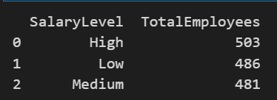
df_salary_summary = (
df_Employee
.groupby('SalaryLevel')
.agg(TotalEmployees=('EmployeeID', 'count'))
.reset_index()
.sort_values('SalaryLevel')
)
print(df_salary_summary)

3.5 Performance Analysis

- Are employees who work overtime more likely to experience lower satisfaction or burnout?
Business Insight Goal: Quantify the effect of excessive workload on wellbeing and productivity.
In SQL :

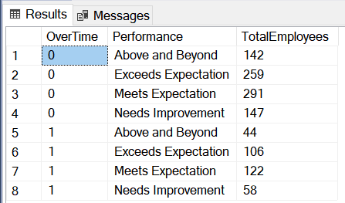

WITH LatestReview AS (
SELECT
EmployeeID,
MAX(ReviewDate) AS MaxReviewDate
FROM PerformanceRating
GROUP BY EmployeeID
)

SELECT
OverTime, r.RatingLevel AS Performance,
COUNT(DISTINCT e.EmployeeID) AS TotalEmployees
FROM PerformanceRating p
JOIN LatestReview lr
ON p.EmployeeID = lr.EmployeeID AND p.ReviewDate = lr.MaxReviewDate
JOIN Employee e
ON p.EmployeeID = e.EmployeeID
JOIN RatingLevel r
ON r.RatingID = p.ManagerRating
GROUP BY OverTime,r.RatingLevel
order by OverTime;

In Python :

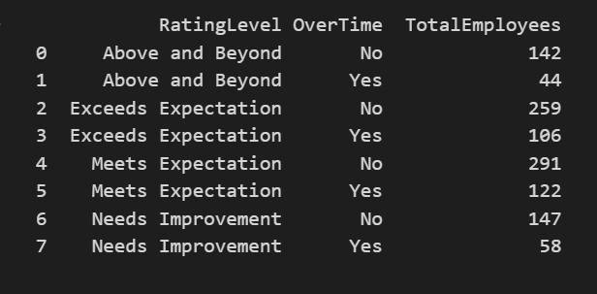

#performance per overtime
# 1. Keep only latest review per employee
latest_rating = (
df_performance.sort_values('ReviewDate')
.groupby('EmployeeID')
.tail(1)
)

# 2. Merge with Employee table to get JobRole and OverTime
latest_rating = latest_rating.merge(
df_Employee[['EmployeeID', 'OverTime']],
on='EmployeeID',
how='left'
)

# 3. Count employees per JobRole, RatingLevel, and OverTime
performance_per_role = (
latest_rating
.groupby([ 'RatingLevel', 'OverTime'], observed=True)
.agg(TotalEmployees=('EmployeeID', 'nunique'))
.reset_index()
.sort_values([ 'RatingLevel', 'OverTime'])
)

print(performance_per_role)

- How does employee performance vary across different job roles within the company?
Business Insight Goal: Identify which job roles demonstrate strong or weak performance levels to support targeted training, resource allocation, and performance improvement initiatives.
In SQL :

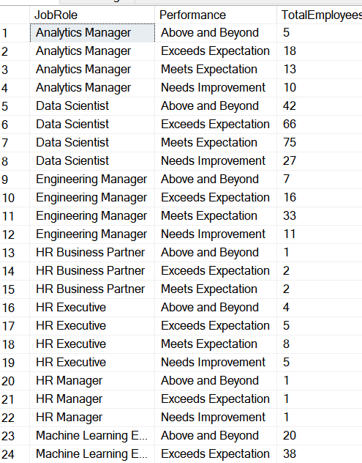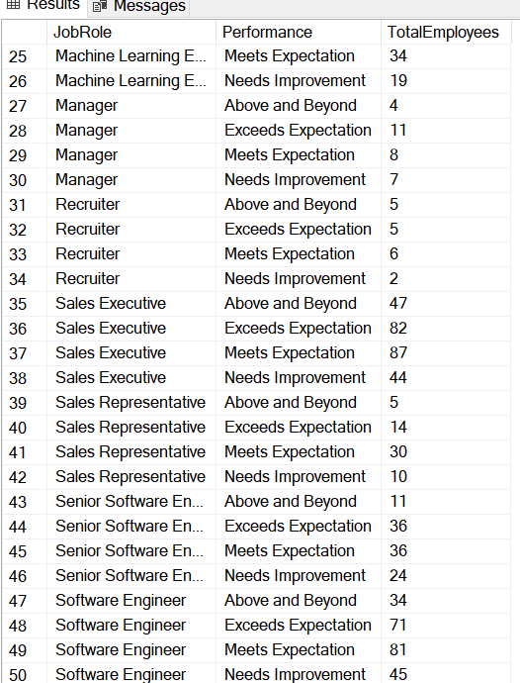

WITH LatestReview AS (
SELECT
EmployeeID,
MAX(ReviewDate) AS MaxReviewDate
FROM PerformanceRating
GROUP BY EmployeeID
)

SELECT
JobRole, r.RatingLevel AS Performance,
COUNT(DISTINCT e.EmployeeID) AS TotalEmployees
FROM PerformanceRating p
JOIN LatestReview lr
ON p.EmployeeID = lr.EmployeeID AND p.ReviewDate = lr.MaxReviewDate
JOIN Employee e
ON p.EmployeeID = e.EmployeeID
JOIN RatingLevel r
ON r.RatingID = p.ManagerRating
GROUP BY JobRole,r.RatingLevel
order by JobRole;

In Python :

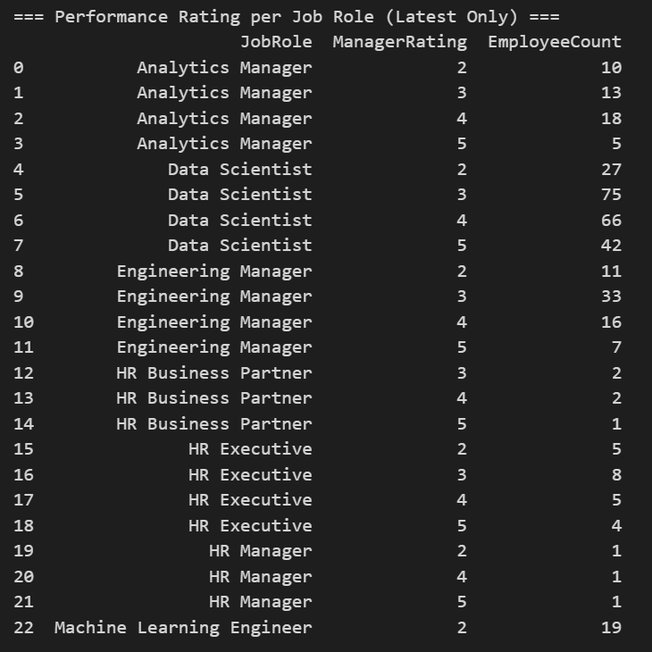

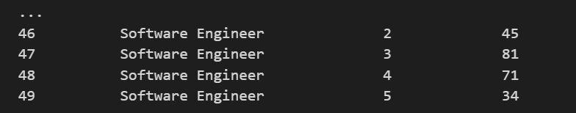

latest_rating = (
df_performance.sort_values('ReviewDate')
.groupby('EmployeeID')
.tail(1) # keep only latest review
)

# --- 2. Merge latest rating with employee table to get JobRole ---
latest_rating = latest_rating.merge(
df_Employee[['EmployeeID', 'JobRole']],
on='EmployeeID',
how='left'
)

# --- 3. Count employees per Job Role and Rating ---
performance_per_jobrole = (
latest_rating
.groupby(['JobRole', 'ManagerRating'], observed=True)
.agg(EmployeeCount=('EmployeeID', 'nunique'))
.reset_index()
.sort_values(['JobRole', 'ManagerRating'])
)

# Display result
print("=== Performance Rating per Job Role (Latest Only) ===")
print(performance_per_jobrole)

- How does employee performance vary across different salary levels within the company?
Business Insight Goal: Identify performance distribution across salary segments to inform compensation planning, reward high performers, and address performance gaps effectively.
In SQL :

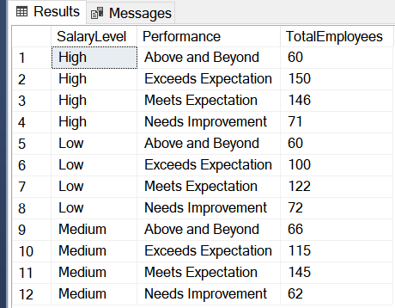

WITH LatestReview AS (
SELECT
EmployeeID,
MAX(ReviewDate) AS MaxReviewDate
FROM PerformanceRating
GROUP BY EmployeeID
)

SELECT
SalaryLevel, r.RatingLevel AS Performance,
COUNT(DISTINCT e.EmployeeID) AS TotalEmployees
FROM PerformanceRating p
JOIN LatestReview lr
ON p.EmployeeID = lr.EmployeeID AND p.ReviewDate = lr.MaxReviewDate
JOIN Employee e
ON p.EmployeeID = e.EmployeeID
JOIN RatingLevel r
ON r.RatingID = p.ManagerRating
GROUP BY SalaryLevel,r.RatingLevel
order by SalaryLevel;

In Python :

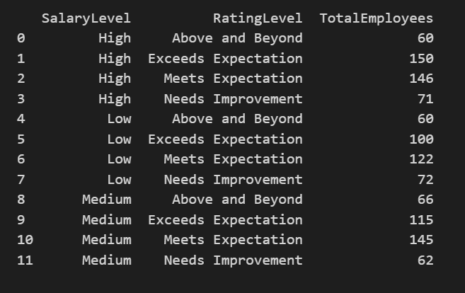

# 1. Keep only latest performance record per employee
latest_rating = (
df_performance.sort_values('ReviewDate')
.groupby('EmployeeID')
.tail(1)
)

# 2. Merge with Employee table to get JobRole and SalaryLevel
latest_rating = latest_rating.merge(
df_Employee[['EmployeeID', 'SalaryLevel']],
on='EmployeeID',
how='left'
)

# 3. Count employees per JobRole, RatingLevel, and SalaryLevel
performance_per_salary = (
latest_rating
.groupby([ 'SalaryLevel', 'RatingLevel'], observed=True)
.agg(TotalEmployees=('EmployeeID', 'nunique'))
.reset_index()
.sort_values(['SalaryLevel', 'RatingLevel'])
)

print(performance_per_salary)

- Classify employees based on their performance and time since last promotion to identify promotion readiness?
Business Insight Goal: To strategically identify and prioritize high-potential employees for promotion, thereby reducing attrition risk among top performers and optimizing talent retention and succession planning.
In SQL :

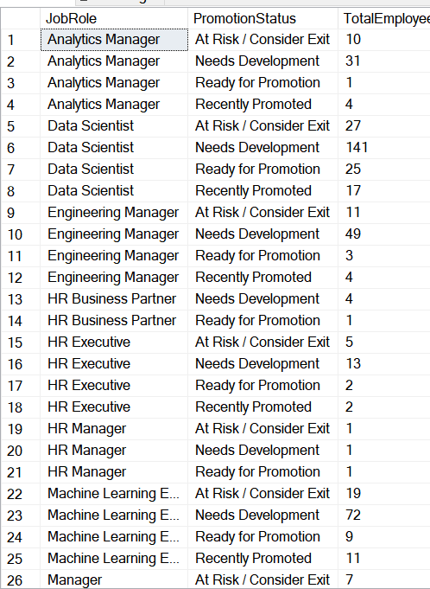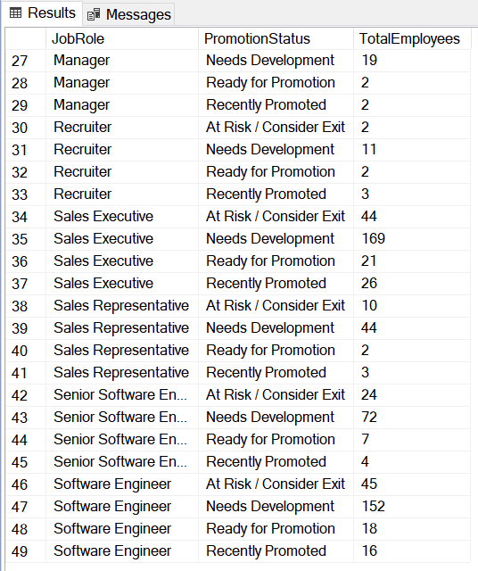

WITH LatestPerformance AS (
SELECT
p.EmployeeID,
p.ManagerRating,
p.ReviewDate,
ROW_NUMBER() OVER (
PARTITION BY p.EmployeeID
ORDER BY p.ReviewDate DESC
) AS rn
FROM PerformanceRating p
),

PerfWithEmployee AS (
SELECT
lp.EmployeeID,
lp.ManagerRating,
e.JobRole,
e.YearsSinceLastPromotion,
CASE
WHEN lp.ManagerRating > 4 AND e.YearsSinceLastPromotion > 3
THEN 'Ready for Promotion'
WHEN lp.ManagerRating > 4 AND e.YearsSinceLastPromotion <= 3
THEN 'Recently Promoted'
WHEN lp.ManagerRating >= 3
THEN 'Needs Development'
WHEN lp.ManagerRating < 3
THEN 'At Risk / Consider Exit'
ELSE 'Unknown'
END AS PromotionStatus
FROM LatestPerformance lp
JOIN Employee e
ON lp.EmployeeID = e.EmployeeID
WHERE lp.rn = 1 -- take latest performance record
)

SELECT
JobRole,
PromotionStatus,
COUNT(DISTINCT EmployeeID) AS TotalEmployees
FROM PerfWithEmployee
GROUP BY JobRole, PromotionStatus
ORDER BY JobRole, PromotionStatus;

In Python :

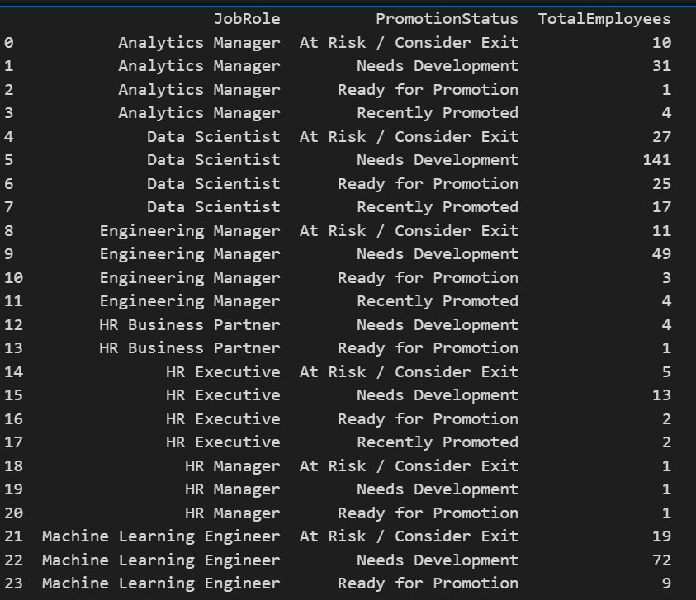

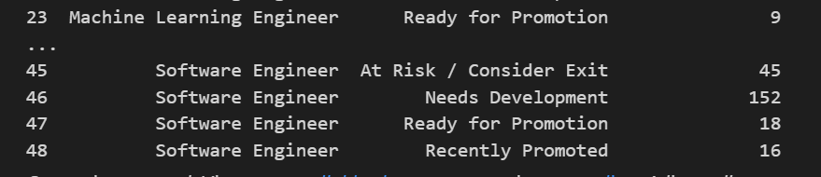
latest_perf = (
df_performance.sort_values('ReviewDate')
.groupby('EmployeeID')
.tail(1)
)

# Merge with Employee table to get JobRole and YearsSinceLastPromotion
latest_perf = latest_perf.merge(
df_Employee[['EmployeeID', 'JobRole', 'YearsSinceLastPromotion']],
on='EmployeeID',
how='left'
)

# Define Promotion Status based on ManagerRating and YearsSinceLastPromotion
conditions = [
(latest_perf['ManagerRating'] > 4) & (latest_perf['YearsSinceLastPromotion'] > 3),
(latest_perf['ManagerRating'] > 4) & (latest_perf['YearsSinceLastPromotion'] <= 3),
(latest_perf['ManagerRating'] >= 3),
(latest_perf['ManagerRating'] < 3)
]

choices = [
"Ready for Promotion",
"Recently Promoted",
"Needs Development",
"At Risk / Consider Exit"
]

latest_perf['PromotionStatus'] = np.select(conditions, choices, default='Unknown')

# Count employees per JobRole and PromotionStatus
promotion_per_role = (
latest_perf.groupby(['JobRole', 'PromotionStatus'], observed=True)
.agg(TotalEmployees=('EmployeeID', 'nunique'))
.reset_index()
.sort_values(['JobRole', 'PromotionStatus'])
)

print(promotion_per_role)

- How do promotion readiness levels differ across various job roles within the company? Business Insight Goal:Provide a clear view of promotion readiness across job roles to support fair advancement decisions and targeted development actions.

In SQL :

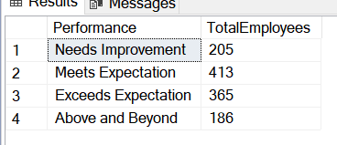
--Employee distribution per manager rating
WITH LatestReview AS (
SELECT
EmployeeID,
MAX(ReviewDate) AS MaxReviewDate
FROM PerformanceRating
GROUP BY EmployeeID
)

SELECT
r.RatingLevel AS Performance,
COUNT(DISTINCT e.EmployeeID) AS TotalEmployees
FROM PerformanceRating p
JOIN LatestReview lr
ON p.EmployeeID = lr.EmployeeID AND p.ReviewDate = lr.MaxReviewDate
JOIN Employee e
ON p.EmployeeID = e.EmployeeID
JOIN RatingLevel r
ON r.RatingID = p.ManagerRating
GROUP BY r.RatingID,r.RatingLevel
order by r.RatingID;

In Python :

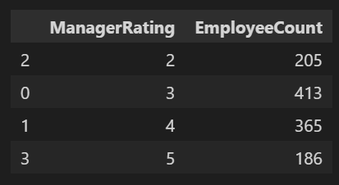

latest_rating = (
df_performance.sort_values('ReviewDate')
.groupby('EmployeeID')
.tail(1) # keep only the latest review
)

# Count employees per rating category
employees_per_rating = (
latest_rating['ManagerRating']
.value_counts()
.reset_index()
)

# Rename columns clearly
employees_per_rating.columns = ['ManagerRating', 'EmployeeCount']

# Sort by rating value
employees_per_rating = employees_per_rating.sort_values(by='ManagerRating')

# Display result
employees_per_rating

Insights

- Overview Dashboard
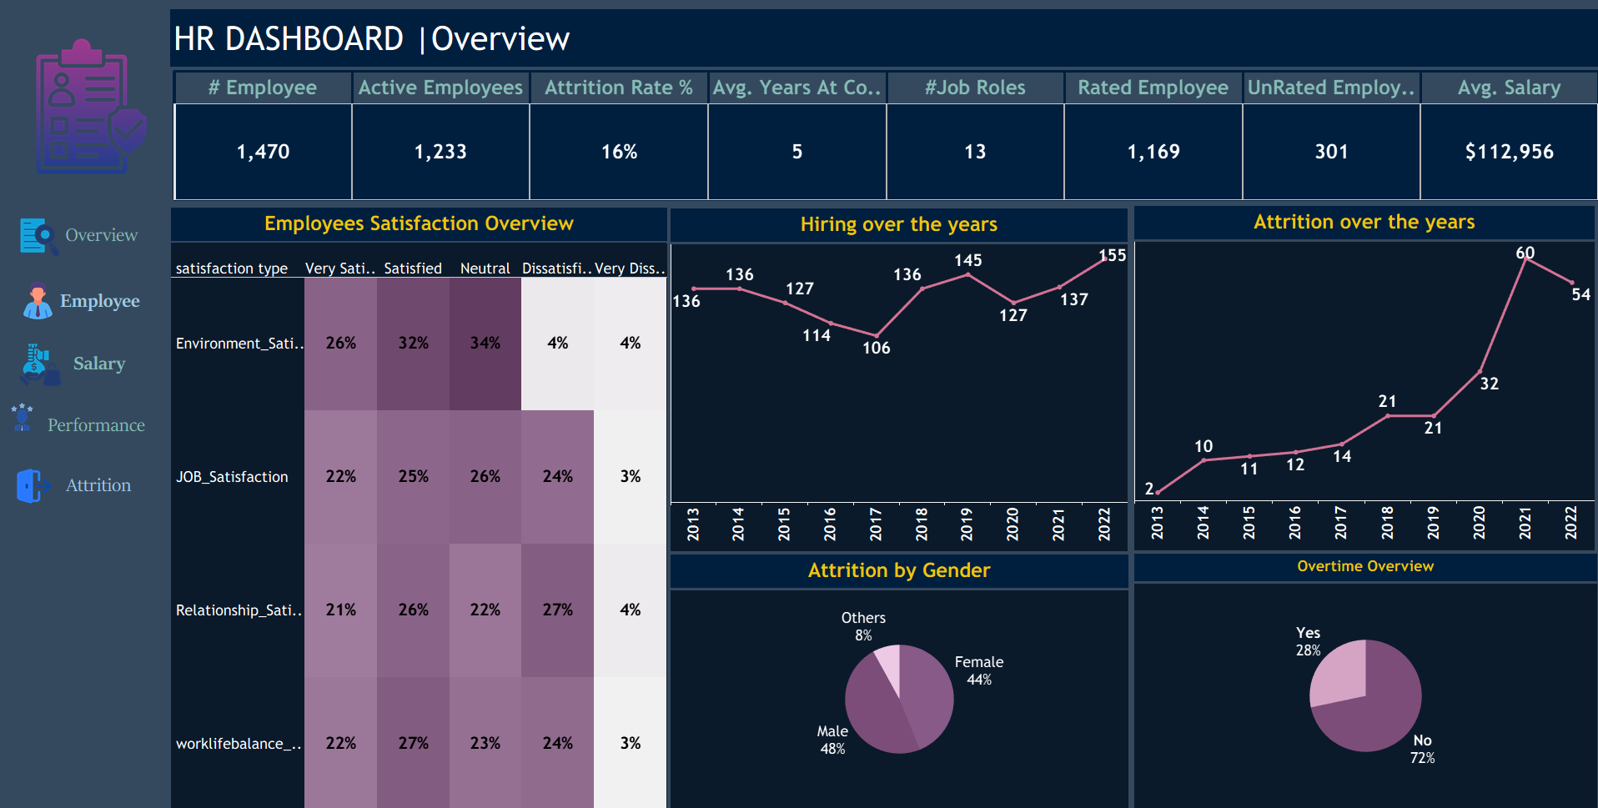

1. Stable Workforce With Moderate Attrition

Total Employees: 1,470

Active Employees: 1,233

Attrition Rate: 16%

Rated Employees: 1,169

Unrated Employees: 301

The organization maintains a strong workforce, with most employees actively contributing, although the attrition rate indicates moderate turnover.

2. Hiring Activity Shows Recent Growth

Hiring decreased gradually from 136 (2013) to 106 (2016).

It then increased steadily, peaking at 155 hires in 2022.

The company has expanded its hiring efforts in recent years, signaling organizational growth and increased workforce demand.

3. Attrition Has Increased Sharply in Recent Years

Attrition rose from 2 employees (2013) to a peak of 60 in 2021, followed by 54 in 2022.

Recent spikes in attrition indicate rising turnover pressure, requiring stronger retention strategies.

4. Employee Satisfaction Shows Strong Neutral-to-Positive Trends

Most employees fall within the neutral to satisfied range, but dissatisfaction in job, relationship, and work–life balance areas may contribute to rising attrition.

5. Attrition by Gender Shows Balanced Impact

Male: 48%

Female: 44%

Others: 8%

Attrition is relatively balanced across genders, showing no major demographic skew.

6. Majority of Employees Do Not Work Overtime

No Overtime: 72%

Overtime: 28%

Overtime levels appear manageable overall, but the overtime group is more likely to contribute to attrition based on broader analysis trends.

7. Workforce Retention Indicator

Average Years at Company: 5

Average Salary: $112,956

Job Roles: 13

The workforce shows solid stability with moderate tenure and competitive compensation.
- Employee Overview

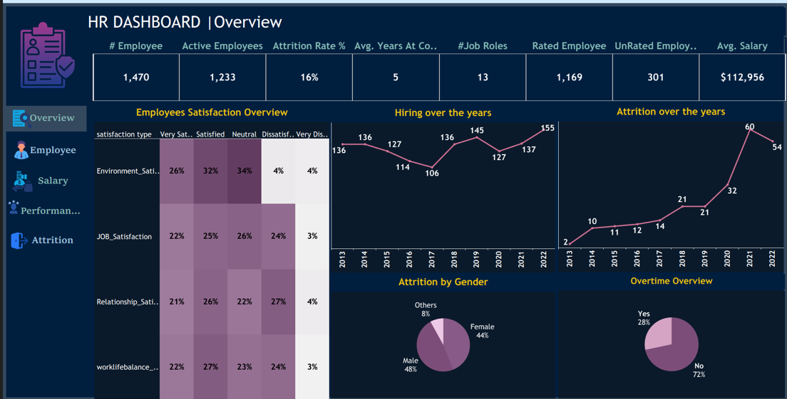

1. Strong and Growing Workforce

The organization employs a total of 1,470 individuals, reflecting a large and diverse workforce.
Active employees number 1,233, indicating that the majority of staff are currently engaged and contributing to operations.

2. Young Workforce Demographic

The company has a young talent base, with an average age of 29.
This suggests a dynamic environment with a focus on early-career professionals.

3. Moderate Employee Retention

Employees stay with the company for an average of 5 years, showing stable but moderate retention levels that support continuity while allowing fresh talent to enter.

4. Broad Job Role Diversity

The structure includes 13 distinct job roles, demonstrating a wide range of functions and specialization within the organization.

5. New York as the Primary Talent Hub

New York hosts 419 employees, making it the most significant location in terms of headcount and a key operational center.

6. Technology Department Dominates Workforce

With 960 employees, the Technology department is by far the largest, highlighting a strong organizational focus on tech-driven operations and innovation.

7. Sales Executive Role Holds Major Share

The Sales Executive position accounts for 327 employees, making it one of the largest and most critical job groups in driving revenue and client relationships.

8. Balanced Gender Representation

Women represent 46% of the workforce, indicating near-gender parity and a balanced representation across teams.

9. Bachelor’s Degree Most Common Education Level

A significant portion of employees (572 individuals) hold a Bachelor’s degree, showing a strong foundation of academically qualified staff.

10. Computer Science Leads Education Fields

Computer Science is the most common field of study, with 440 employees, reflecting the company’s emphasis on technical expertise.

11. Majority of Employees Are Early-Career (18–29)

The 18–29 age group includes 955 employees, reinforcing the youthful nature of the workforce and a strong pipeline of early-career talent.

12. High Proportion of Married Employees

There are 624 married employees, indicating a mature demographic in terms of personal life stability.

- Employee Attrition Analysis

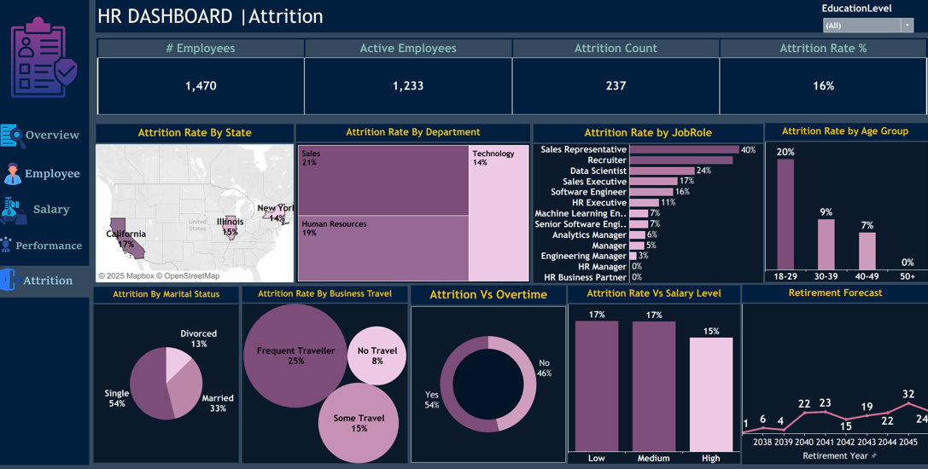

1. Overall Attrition Overview
• Total number of employees: 1,470
• Active employees: 1,233
• Attrition count: 237
• Overall attrition rate: 16%

Insight:
The attrition rate is moderate but indicates the need for targeted retention strategies in high-risk groups.

2. Attrition by State
• Highest attrition percentages occur in:
• California (17%)
• Illinois (15%)
• New York (14%)

Insight:
States with higher attrition may be influenced by increased job competition, cost of living, or workload stress.

3. Attrition by Department
• Sales (21%) holds the highest turnover rate, followed by:
• Human Resources (19%)
• Technology (14%)

Insight:
Departments with intensive workloads, performance pressure, or frequent interpersonal interactions experience higher turnover.

4. Attrition by Job Role
• Highest turnover roles include:
• Sales Representative (40%)
• Recruiter (24%)
• Data Scientist (20%)

Insight:
Job roles associated with high targets, market competition, or skill scarcity show significantly higher attrition.

5. Attrition by Age Group
• 18–29 years: 20% (highest)
• 30–39 years: 9%
• 40–49 years: 7%
• 50+ years: 0%

Insight:
Younger employees are more likely to leave the organization, signaling a need for improved career development and engagement initiatives.

6. Attrition by Marital Status
• Single: 54%
• Married: 33%
• Divorced: 13%

Insight:
Single employees show a higher likelihood of turnover, potentially due to greater mobility and fewer personal constraints.

7. Attrition by Business Travel
• Frequent Travel: 25%
• Some Travel: 15%
• No Travel: 8%

Insight:
Increased business travel correlates strongly with higher attrition, likely due to fatigue or work–life imbalance.

8. Attrition vs. Overtime
• Overtime (Yes): 54%
• Overtime (No): 46%

Insight:
Employees working overtime exhibit a higher turnover rate, indicating that workload intensity contributes to attrition.

9. Attrition vs. Salary Level
• Low Salary: 17%
• Medium Salary: 17%
• High Salary: 15%

Insight:
Salary level shows minimal impact on attrition differences, suggesting compensation is not the primary driver of resignation.

10. Retirement Forecast
• Projected retirement peaks occur in:
• 2041 (22 employees)
• 2043 (23 employees)
• 2045 (32 employees)

Insight:
A significant number of employees are expected to retire within the next decade, emphasizing the need for succession planning.

Overall Conclusion

Attrition is primarily influenced by job roles, travel frequency, departmental pressure, and younger age groups, while salary appears to be a secondary factor.
These findings highlight the importance of focusing on workload management, improved career pathways, and targeted retention programs to reduce turnover effectively.

- Salary Analysis and Insights

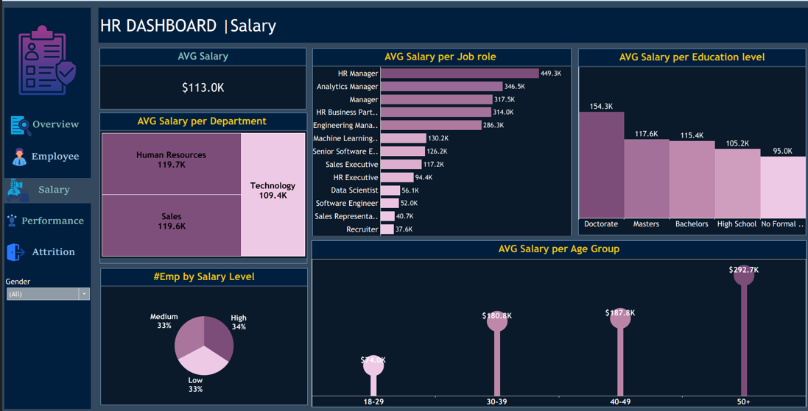

1. Managerial Roles Receive the Highest Compensation

Managerial and strategic positions represent the top salary tier in the organization.

HR Manager: $449K (highest)

Analytics Manager: $346K

Manager: $317K

This reflects the company’s strong investment in leadership and analytical decision-making roles.

2. Higher Education Levels Drive Higher Salaries

There is a clear positive relationship between education level and salary.

Doctorate: $154K (highest education-based average)

Master’s / Bachelor’s: $115K–$117K

This pattern aligns with global compensation trends where advanced qualifications command higher pay.

3. Salary Progresses Significantly With Experience

Older age groups, typically representing more experienced employees, earn substantially higher salaries.

18–29: $74K

30–39: $180K

50+: $292K (highest age group)

This indicates that the organization heavily values experience and tenure in its compensation structure.

4. HR and Sales Are the Highest-Paid Departments

The departments with the highest average salaries are:

Human Resources: $119.7K

Sales: $119.6K

This suggests these functions play a strategic business role and receive competitive compensation accordingly.

5. Salary Level Distribution

Salary levels are nearly evenly distributed:

High: 34%

Medium: 33%

Low: 33%
This balanced distribution suggests an equitable pay structure across the workforce.

- Performance Analysis
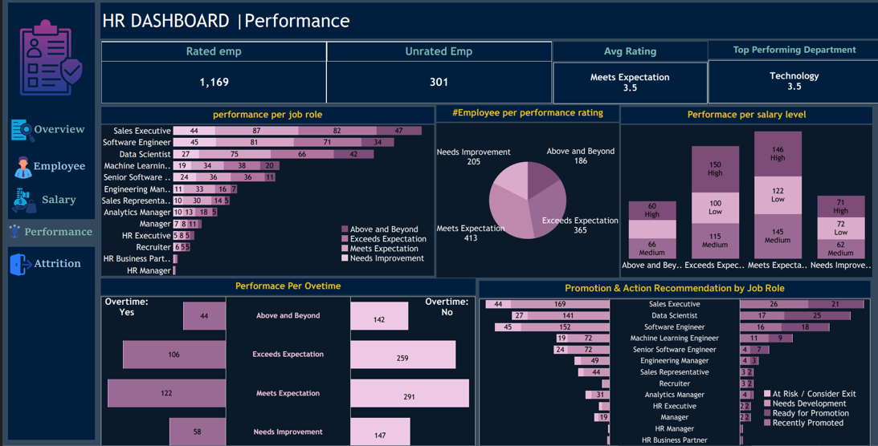

1. Performance Coverage
• Rated Employees: 1,169
• Unrated Employees: 301
• Average Performance Rating: 3.5 (Meets Expectations)
• Top-Performing Department: Technology (Avg. 3.5)

Insight:
A significant number of employees (≈20%) remain unrated, which may impact fairness in promotions, salary reviews, and development planning.

2. Performance by Job Role

High-performing roles include:
• Sales Executive
• Software Engineer
• Data Scientist
These roles demonstrate a notable number of employees rated Above and Beyond or Exceeds Expectations.

Lower-performing roles include:
• HR Manager
• HR Business Partner
• Recruiter

Insight:
Technical and sales-based roles show strong performance, while HR-related functions require additional support, training, and performance improvement plans.

3. Performance by Salary Level
• High Salary Level employees show the highest number of “Above and Beyond” ratings.
• Medium Salary Level shows balanced performance, mostly “Meets Expectations.”
• Low Salary Level has the largest portion of “Needs Improvement.”

Insight:
There is a positive relationship between salary level and performance, suggesting that higher compensation aligns with higher motivation or experience levels.

4. Performance by Overtime

Overtime = Yes
• Shows higher counts in Exceeds Expectation (106) and Above and Beyond (44).

Overtime = No
• Majority fall under Meets Expectation (291).

Insight:
Employees working overtime demonstrate stronger performance, indicating high engagement. However, overtime should remain optional to avoid burnout.

5. Promotion & Action Recommendations

High promotion readiness appears in:
• Sales Executive
• Data Scientist
• Software Engineer

Roles requiring development or performance improvement:
• HR functions
• Recruitment roles
• Entry-level managerial positions

Insight:
The organization has clear promotion potential in technical and sales roles, while support functions need structured development and training programs.

Overall Performance Insight

Employee performance is generally stable, with strong results in technical and sales departments. However, the organization must address gaps in HR-related roles, reduce the number of unrated employees, and maintain a balanced approach to overtime usage. Promotion pathways are most promising for high-performing technical and data-focused positions.

Recommendations

1️⃣ Short Term Recommendations (0–3 Months)

Goal: Quick fixes to address immediate operational issues.

      - Complete Missing Performance Ratings
- 301 employees (~20%) have no performance ratings.
- Impacts salary reviews, promotions, and development plans.
- Action: Mandatory performance review cycle within the first month.
      - Review High Attrition Segments
- Highest attrition in:
- Age Group 18–29
- Sales & HR departments
- Sales Representative roles
- Frequent travelers
- Action: Conduct exit interviews + pulse surveys, offer quick retention bonuses or flexible work options.

      - Fix Salary Imbalances
- Technical roles paid significantly less than HR & Managers despite high attrition.
- Action: Benchmark salaries against the market and adjust low salary bands immediately.

      - Overtime Management
- High overtime linked to high performance but poses long-term risks.
- Action: Organize overtime (optional, paid, monitored).

      - Improve Employee Engagement
- Very Satisfied employees are only 3–4%, high Neutral ratings indicate weak engagement.
- Action: Quick wins via recognition programs and manager feedback sessions.

2️⃣ Mid-Term Recommendations (3–12 Months)

Goal: Build stronger systems and improve quality & stability.

        - Structured Career Pathing
- Low salary employees lack visibility for promotion, leading to high attrition in early-career groups.
- Action: Clear career ladder, promotion criteria, and mentoring programs.

        - Create Salary Bands & Internal Equity Review
- Large gaps between departments and roles (e.g., HR Manager ~346K vs. Software Engineer ~52K).
- Action: Build pay grades, conduct internal equity audit, implement transparent compensation policy.

        - Build Consistent Performance Management System
- Many employees unrated; manager average rating = 3.
- Action: Train managers, standardize rating rubrics, hold calibration sessions.

        - Reduce Attrition in High-Risk Departments
- Focus: Sales, HR, Technology.
- Action: Targeted development plans, retention packages, optimized workloads.

        - Introduce Employee Satisfaction Program
- Low Very Satisfied scores across all satisfaction types.
- Action: Engagement program with well-being activities, work-life balance initiatives, team-building, and recognition system.

3️⃣ Long-Term Recommendations (12+ Months)

Goal: Build a sustainable, scalable HR environment.

        - Build Full HR Analytics System
- Implement predictive attrition models, AI-based salary fairness checks, and workforce planning dashboards.
- Goal: Data-driven decision-making.

        - Succession Planning & Leadership Pipeline
- Address high attrition in young employees.
- Action: Leadership development programs, identify high-potential employees, prepare future managers internally.
        - Long-Term Compensation Strategy
- Link salaries to performance, market benchmarks, and years of service.
- Adjust technical roles to reduce attrition.

        - Culture Transformation
- Overall satisfaction medium, Very Satisfied low → long-term risk.
- Action: Build culture of growth, recognition, transparency; upskill managers.

        - Strategic Workforce Planning
- Anticipate waves of retirements.
- Action: Plan recruitment and succession proactively.
⭐ Core HR Priorities (Top 5 Focus Areas Across All Dashboards)

          - Mandatory Performance Review
- 20% of employees lack performance ratings.
- Critical for salary reviews, promotions, and attrition prediction.

          - Reduce High Attrition in Key Segments
- Young employees (18–29), Sales, HR, Technical roles, and frequent travelers.
- Action: Exit interviews, improved working conditions, retention initiatives.

          - Address Salary Gaps
- Technical roles severely underpaid vs. HR/Managers.
- Action: Restructure salary scales, especially for technical roles.

          - Improve Employee Engagement
- Very Satisfied = 3–4%, most employees Neutral.
- Action: Recognition programs, work-life balance initiatives, manager feedback.

          - Implement Clear Career Paths
- Low visibility for promotion leads to attrition.
- Action: Establish career ladders and promotion criteria for all roles.

